**Development of**

**Job Recruitment Portal**



**Mohammad Ahsan Junaid**

**Abdul Rehman**

**Thesis submitted in partial fulfillment of requirements for the Degree of Bachelor of Sciences in Computer and Information Sciences**

**Department of Computer and Information Sciences, Pakistan Institute of Engineering & Applied Sciences, Nilore, Islamabad, Pakistan.**

**May, 2023**



***In the name of Allah, the Entirely Merciful, the Especially Merciful***

**Department of Computer and Information Sciences,**

**Pakistan Institute of Engineering and Applied Sciences, Nilore, Islamabad 45650, Pakistan**

**Declaration of Originality**

I hereby declare that the work contained in this thesis and the intellectual content of this thesis are the product of my own work. This thesis has not been previously published in any form nor does it contain any verbatim of the published resources which could be treated as an infringement of the international copyright law.

I also declare that I do understand the terms ‘copyright’ and ‘plagiarism,’ and that in case of any copyright violation or plagiarism found in this work, I will be held fully responsible for the consequences of any such violation.



**Mohammad Ahsan Junaid Abdul Rehman**

**Certificate of Approval**

***This is to certify that the work contained in this thesis entitled***

**“Development of a Web Application, Job Recruitment**

**Portal”**

***was carried out by***

**Mohammad Ahsan Junaid**

**Abdul Rehman**

***Under our supervision and that in our opinion, it is fully adequate, in scope and quality, for the degree of BS Computer and Information Sciences from Pakistan Institute of Engineering and Applied Sciences (PIEAS).***

***Approved by:***

**Signature: Supervisor: *Dr. Anila Usman***

**Signature: Co-Supervisor: *Sir Irfan Hameed***

***Verified by:***

**Signature: Head, DCIS: Dr. Javaid Khurshid**

**Stamp:**

**This project is dedicated to our beloved family, teachers and friends, who offered us unconditional love and support throughout the course of this project.**

**Acknowledgement**

First and foremost, I would like to thank Allah, our sole creator, helper, guider, endower of everything that we have in our lives and forgiver for all the sins that we are guilty of committing. If it wasn’t for His enormous bounty, we would have never achieved anything in our lives and be lost.

I express my sheer appreciation to my supervisor Dr. Anila Usman. She has always been keen on helping and has provided me the guidance on every aspect concerning my project. Even with her grueling schedule she has always taken out time to clear away our doubts or solved any problem which impeded my work.

I also express my sheer appreciation to my co-supervisor, Sir Irfan Hameed. He has always been there for me whenever I needed him, and he has provided me with the necessary guidance on how to proceed with my project. He has helped me immensely in understanding the fundamentals of web development.

Lastly but most importantly I would express my eternal gratitude towards my parents who have always been our backbone throughout the years and have never let me down no matter what.

**Mohammad Ahsan Junaid**

**Abdul Rehman**

**PIEAS, Nilore, Islamabad**

**Table of Contents**

Contents

Abstract 2

Chapter 1: Introduction 3

1.1. Problem Definition 3

1.2. Proposed System 4

1.3 System Functions 5

Chapter 2: Literature and Tech Review 6

2.1. Management Portal 6

2.2. Programming Languages and Frameworks 6

2.2.1. HTML 6

2.2.2. CSS 7

2.2.3. JavaScript 7

2.2.4. Bootstrap 8

2.2.5. PHP 8

2.2.6. MySQL 8

2.3. Software’s and Technologies Used 9

2.3.1. XAMPP 9

2.3.2. Visual Studio 9

2.3.3. Apache 9

2.3.4. GitHub 10

2.3.5. phpMyAdmin 10

2.3.6. 000WebHost 10

Chapter 3: Software Design & Architecture 11

3.1. System Overview 11

3.2 Functional Requirements 11

3.2.1. Users / Applicant 11

3.2.2. Employers 11

3.3 Non Functional Requirements 12

1. Security 12

2. Availability 12

3. Scalability 12

4. Performance 12

5. Usability 12

3.4 System Architecture 13

3.4.1. Client-Side Elements 13

3.4.2. Components for the server 13

3.4.3. Infrastructure Elements 13

3.4.4. Application Layer 13

3.4.5. Database Layer 13

3.5. Database Design 14

3.5.1. Data Storage 14

3.5.2. Data Security 14

3.5.3. Data Organization 14

3.5.4. Data Scalability 14

3.5.5. Data Persistence 14

3.6. Scope 15

3.6.1. Features Falling Within Scope 15

3.6.2. Scope in Real World Use 16

Chapter 4: Implementation 17

4.1. Technology & Tools Used 17

4.2. Front End Development 17

4.2.1. Home Page 17

4.2.2. Job Posting Page 19

4.2.3. Login Page 20

4.2.4. Applicant Login Page 21

4.2.5. Employer Login Page 22

4.2.6. Sign Up Page 23

4.2.7. Applicant Registration Page 24

4.2.8. Employer Registration Page 25

4.2.9. Applicant Dashboard – Edit Profile 26

4.2.10. Applicant Dashboard – Job Applications 27

4.2.11. Applicant Dashboard – Mailbox 28

4.2.12. Applicant Dashboard – Read / Reply Mail 29

4.2.13. Applicant Dashboard – Settings 30

4.2.14. Employer Dashboard 31

4.2.15. Employer Dashboard – Company Details Page 32

4.2.16. Employer Dashboard – Create Job Page 33

4.2.17. Employer Dashboard – Posted Jobs 34

4.2.18. Employer Dashboard – Job Applications Page 35

4.2.19. Employer Dashboard – Mailbox 36

4.2.20. Employer Dashboard – Reply / Create Mail Page 37

4.2.21. Employer Dashboard - Settings 38

4.2.22. Employer Dashboard – Applications Database 39

4.2.23. Admin Dashboard 40

4.2.24. Admin Dashboard – Active Jobs 41

4.2.25. Admin Dashboard – Applicants Database 42

4.2.26. Admin Dashboard – Employers Database 43

4.3. Backend Development 44

4.3.1. Administrator’s Backend 44

4.3.2. Employer’s Backend 44

4.3.3. User’s Backend 45

4.4. Database Structure 46

4.4.1. Admin Table 47

4.4.2. Apply_Job Table 47

4.4.3. Cities Table 48

4.4.4. Companies Table 49

4.4.5. Countries Table 50

4.4.6. Job Post Table 50

4.4.7. Mailbox Table 51

4.4.8. Reply Mail Table 52

4.4.9. States Table 53

4.4.10. Users Table 54

4.5. Web Hosting 56

4.5.1. Backend Management 56

4.5.2. Database Management 57

Chapter 5: Structure 58

5.1. Front End Structural Diagram 58

5.2. Backend and Database Diagrams 59

5.2.1. ER Diagram 59

5.2.2. Use Case Diagram 60

5.2.3. Context Diagram 61

5.2.4. Relational Schema 62

Chapter 6: User Roles 63

6.1 . Administrator 63

6.2 . Employer 63

6.3 . Applicant / Candidate 63

Chapter 7: Conclusion and Future Works 64

7.1. Conclusion 64

7.2. Future Works 65

7.2.1. Live Interviewing: 65

7.2.2. Enhanced Search and Filtering: 65

7.2.3. Personalized Recommendations: 65

7.2.4. Mobile Application: 65

References 66

Appendix A – Installation and Setup 68

Appendix B – Libraries Used in Project 69

● Bootstrap 69

• Font Awesome 69

• AdminLTE 69

• Data Tables 69

**Table of Figures**

Figure 4.1. Home Page .................................................................................................................18

Figure 4.2. Job Posting Page.........................................................................................................19

Figure 4.3. Login Page .................................................................................................................20

Figure 4.4. Applicant Login..........................................................................................................21

Figure 4.5. Employer Login..........................................................................................................22

Figure 4.6. Sign Up Page .............................................................................................................23

Figure 4.7. Applicant Sign Up......................................................................................................24

Figure 4.8. Employer Sign Up .....................................................................................................25

Figure 4.9. Applicant Dashboard .................................................................................................26

Figure 4.10. Applicant Dashboard................................................................................................27

Figure 4.11. Applicant Dashboard................................................................................................28

Figure 4.12. Applicant Dashboard................................................................................................29

Figure 4.13. Applicant Dashboard................................................................................................30

Figure 4.14. Employer Dashboard ...............................................................................................31

Figure 4.15. Employer Dashboard................................................................................................32

Figure 4.16. Employer Dashboard................................................................................................33

Figure 4.17. Employer Dashboard................................................................................................34

Figure 4.18. Employer Dashboard................................................................................................35

Figure 4.19. Employer Dashboard................................................................................................36

Figure 4.20. Employer Dashboard................................................................................................37

Figure 4.21. Employer Dashboard................................................................................................38

Figure 4.22. Employer Dashboard................................................................................................39

Figure 4.23. Admin Dashboard.....................................................................................................40

Figure 4.24. Admin Dashboard.....................................................................................................41

Figure 4.25. Admin Dashboard.....................................................................................................42

Figure 4.26. Admin Dashboard.....................................................................................................43

Figure 4.27. Admin Backend.........................................................................................................44

Figure 4.28. Applicant Backend....................................................................................................45

Figure 4.29. User Backend............................................................................................................45

Figure 4.30. Database....................................................................................................................46

Figure 4.31. Admin Table ............................................................................................................47

Figure 4.32. Apply Job Table .......................................................................................................48

Figure 4.33. Cities Table...............................................................................................................48

Figure 4.34. Companies Table ......................................................................................................49

Figure 4.35. Countries Table ........................................................................................................50

Figure 4.36. Job Post Table...........................................................................................................51

Figure 4.37. Mailbox Table ..........................................................................................................52

Figure 4.38. Reply Mailbox Table................................................................................................53

Figure 4.39. State Table................................................................................................................53

Figure 4.40. User Table.................................................................................................................55

Figure 4.41. User Table.................................................................................................................55

Figure 4.42. Hosting Page ............................................................................................................56

Figure 4.43. Hosting Backend Page .............................................................................................57

Figure 4.44. Hosting Database......................................................................................................57

Figure 5.1. Structural Diagram .....................................................................................................58

Figure 5.2. ER Diagram.................................................................................................................59

Figure 5.3. Use Case Diagram ......................................................................................................60

Figure 5.4. Context Diagram ........................................................................................................61

Figure 5.5. Relational Schema ......................................................................................................62

# Abstract

The Job Recruitment Portal is a web application which has been designed to help employers as well as applicants to improve the already existing job recruitment process, it aims to connect job applicants/candidates and employers through an efficient and user-friendly UI, allowing a seamless job search, applying to jobs, checking CV’s, details of applicants and selection procedures. The administrator, employers, and applicants are the three main actors in this portal. Where the super user, which is the “Admin” is allowed to manage the database, monitor system statistics, delete accounts of applicants and employers and perform other administrative tasks. Next we have “Employers” who can post jobs, review applicant profiles, select or reject applicants, and download resumes as well as contact applicants through the in-built mailbox system in this. Finally, we have our last type of user called “Applicants” or “Candidates” who can search available job listings, apply for open positions, upload their CV/resumes, contact employers for queries etc. without having to upload documents every time.

So we can say that this ‘Job Recruitment Portal’ is to improve the efficiency and effectiveness of the recruitment process for both employers and applicants by providing a platform for job posting, searching, applying and managing the applicants as well as their applications. Which is password protected, that is also encrypted in the database to make the system a secure system, it also utilizes number of technologies and frameworks to achieve its goal. Here in this thesis we will go through the design, development, and evaluation of the Job Recruitment Portal, along with its performance and potential future enhancements.

# Chapter 1: Introduction

The Job Recruitment Portal aims to revolutionize the old-fashioned recruitment process by giving employers, hiring actor, and applicants/candidates, applying actors, with an efficient platform. Traditional methods of recruitment usually cause delays due to the manual selection procedure, also bears heavy costs due to more man hours and resources but this project takes in account these issues by giving a solution. It has three actors: administrator, employers, and applicants. The database and system statistics are managed by the administrator, whereas posting jobs, reviewing applicants, and downloading resumes is done by employers and searching jobs and applying to them is done by applicants. The result of this project contributes to the area/field of job recruitment, which has a lot real-world applications and provide guidance for future works as well, where the goal is to improve the system by making it more efficient, cost wise and time wise, along with giving a better experience to its users by streamlining the whole process.

## Problem Definition

Traditional recruitment methods frequently face a number of challenges that impede the process's efficiency and effectiveness.

* Handling a large volume of job applications manually is time-consuming and labor-intensive, resulting in delays and potential oversight of qualified candidates.
* Job seekers struggle to find relevant opportunities among numerous sources, resulting in potential positions being missed.
* The lack of standardized formats for resumes and job postings makes objective candidate evaluation and decision-making difficult.
* Without a centralized system, employers struggle to effectively track and manage applications.
* Limited Reach and Narrow Candidate Pool: Conventional techniques, such as newspaper ads or physical job postings, may only reach a narrow pool of individuals. Due to this, there may be a lack of diversity and skilled applicants who are not actively looking for work through conventional routes may go unnoticed.
* High costs: Conventional hiring practices can be pricey, including participating in job fairs and newspaper advertising. Advertising, travel, and other associated costs may require organizations to set aside large sums, which can be difficult, especially for startups and small businesses with scarce resources.
* The management of applications, paperwork, and communication can be inefficient and prone to mistakes when done manually. Traditional techniques frequently lack automated components.

## Proposed System

The solution for this is a modern “Job Recruitment Portal”, As the world moves on to a digital era, searching for Jobs or finding the right Employee for one, like all other aspects of daily life, are being shifted to be online, saving time, human resources, accessible and providing ease of use. We intended to create a platform that will automate the process where organizations can put up job vacancies, where applicants can go through them and apply in the right job.

Where employers would have the ease of checking through CV’s and selecting the suitable candidates etc. And applicants will find a platform that will allow them to apply in multiple jobs according to their qualifications easily as well as get side-by-side updates.

It is web-based platform, with a good UI/UX having a Landing page, Job Vacancies Page from where one can apply into preferred job after registering with the system as an applicant where email validation shall be done, then provide data and upload their CV and apply for jobs they want, they can also search by the search bar and apply search filters for their needs like locations, experience requirements etc. Employers would have access to a job posting page where they set the requirements and the details of the job like title, salary, details etc. This system has a database for all records of jobs i.e. Job Titles (with details), Applications (CV attached, Data provided) as well as details of users such as employers, and most importantly the applicants like their Names, CNIC, Addresses, Qualifications, and so on.

To secure all this data and avoid mishaps, security measures will be taken starting off with proper Authorization being implemented like access-controls over user types, where an applicant can only view, update his/her own data rather than having access of others, the employer only accessing data of applicants who have applied to his posted job, Admin having access of everything including the database etc.

Applicants/Candidates can apply in one or more jobs with easy without entering same data (name, CNIC, Addresses etc.) again for each job they apply. On the employers end they can check all the applications to a certain job, contact applicants regarding concerns through in-built communication channel and download CV’s and data of applicants for further processing if needed.

## 1.3 System Functions

The following are key system functions:

* **User Registration and Login Authentication:**

Employers and Applicants can register and create accounts on the portal, that are password protected and encrypted in database, hence even admin cannot see them.

User login authentication ensures secure system access and protects user data.

* **Job Posting and Management:**

Employers can create and post job openings, describing the job's details and requirements.

As needed, job listings can be edited, updated, or removed.

* **Filtering and Job Search:**

Applicants can use specific criteria to search for available jobs. Filtering options allow applicants to refine their search results and find relevant job opportunities.

* **Management of Applicant Profiles:**

Employers can review applicant profiles, including resumes, can establish contact if they have applied to any job posting by that employer.

* **Candidate Selection:**

Based on their suitability for the job, employers can mark applicants as selected / rejected.

Selected candidates can be contacted for interviews, assessments, or other stages of the selection process through the in-built mailbox.

* **Download Resume/CV:**

Employers can download applicants' resumes or CVs for offline review or further evaluation.

* **Management and the Admin Dashboard:**

The system administrator has access to a comprehensive dashboard for system management.

Admin functions include approval of employer account, managing users, databases, and generating system statistics. Admin reserves rights to delete any posted job, or employer account as well from here.

* **In Built Mailbox:**

The in-built mailbox offers applicants and employers to communicate any misunderstandings or important notices and details.

* **Change Password / Deactivate Accounts:**

Employers and applicants can both use this option to modify their passwords inside the portal. For account security, users can reset their passwords and access their account settings, also users are also able to deactivate their accounts within the portal.

# Chapter 2: Literature and Tech Review

Chapter 2 contains many basic concepts, technologies and frameworks that are significant in the conduct and development of the project titled “*Job Recruitment Portal”.* From simple languages to complex backend frameworks and applications that were used for the development process.

## Management Portal

Our project, the job recruitment portal is type of an information management portal, and Information systems are large, linked collections of information, data and processes. They are employed in virtually every element of human life, business, and industry, like schools have library management systems to employee management systems and so on.

The "Information system" in technology means any tool or information system that allows us to gather and utilize data / information. Information systems can be utilized to give aid inside a company or for personal benefit.

Hence a good information system allows the user to quickly access and react to information. Where the system users are to have access to the most up-to-date information whenever they need it.

## Programming Languages and Frameworks

In this section, different programming languages that have been used to develop this system are discussed. It includes simple frontend structural languages to backend languages that went in.

### HTML

We have used HTML (Hypertext Markup Language) for creating and organizing web pages, where it has tags that specify the structure and presentation of content. Text, links, images, videos, links, forms are added in HTML and shown on the browser. Web designers use html to structure and format the content. HTML is one of the main languages that are used in web development, it ensures cross - platform compatibility and is supported by all major web browsers.[1]

### CSS

We used CSS to style the HTML. Web developers use CSS as it separates content from presentation giving more flexibility and consistency across pages. We can apply different colors, layout, animations and fonts to HTML using CSS. It supports efficient web development as we can reuse styles on multiple pages which loads the web page faster because lesser the code, faster the page. it is easy to update and maintain websites because of CSS. It improves the experience and presentation of content of web site.it is not dependent on html. There are many tags in CSS such as <style> tag is used to style the document, to style para we use <p> tag and define the color, font we need. <div> tag allows to group and style content on web page.[2]

### JavaScript

JavaScript is used to add interactivity, functionality and dynamic behavior to the web sites. It runs on user’s browser. It is used to handle user’s interaction, manipulating html and CSS and validation etc. it can update the page contents according to users’ action without reloading the page. It is important part of web development as it enhances user experience, we can create responsive user interfaces, validate the data entered by user and perform calculations and much more. All major web browsers support JavaScript. We can use it directly within html files or in separate files to improve user experience and functionality of website.[3]

### Bootstrap

Bootstrap is a famous front end framework, it has collection of templets, styles and CSS and JS. it is used to create responsive web applications. It makes the process of designing and styling the web site easy by providing the pre-built components such as forms, buttons, navigation bars and grid etc. it contains JavaScript plugins such as dropdowns etc. the plugins improves the functionality without writing JavaScript code. it helps developers to easily customize the website by providing customizable prebuilt themes and styles, Also it reduces the time needed to create a website as there is no need to write a code from scratch for its development.[4]

### PHP

PHP is a famous language used in web development. It is server-side programming language. It is embedded with html to give a mix presentation and logic. PHP is used to create dynamic pages. PHP is run on server side before the html is sent to client browser. it has a wide range of uses such as file handling, database connectivity etc. PHP is simple and flexible. It is compatible with many databases such as oracle and MySQL. It has in-built libraries and functionalities that makes the process of creating websites easy. It runs on multiple operating systems and servers.it helps developers to create scalable web applications because of its large community, frameworks and libraries.[5]

### MySQL

It is a relational database management system, it is used for managing, storing and retrieving data. It used to handle large data efficiently and securely web application and other systems use MySQL. It provides features such as data security, integrity, transection support and access controls. It is used along with python, JS and PHP to create dynamic and responsive web applications allowing to store and retrieve data and perform database queries. It a main choice for both enterprise-level and small-scale projects as it offers functions like ease of use, performance and reliability. MySQL is known for its speed, dependability, and simple use which makes it a popular choice for smaller projects to corporate and enterprise-level applications.[6]

## Software’s and Technologies Used

In this section, different technologies and tools that are used to develop this portal are discussed below:

### XAMPP

XAMPP is an open source software package that provides local environment to develop and test applications. Xampp has apache that hosts web application locally, which is used by us for our project too. It also has MySQL to store and retrieve data and it is also used by us for our project locally, it has PHP which is a server side scripting language to create dynamic and interactive applications. It mainly has the MariaDB database, the Apache HTTP Server, script interpreters for the PHP and Perl programming languages.

By using XAMPP we can make our local server environment eliminating the need for internet connection or remote server during development and testing. A WAMP webserver stack can be deployed and instantiated with ease using XAMPP.[7]

### Visual Studio

Visual studio is developed by Microsoft. it is t is used to develop applications for many platforms in many languages like C, C#, C++, Python etc. it is easy to use and it provides various tools such as project management, debugger, code editor. It is widely used for development and deploying applications and software across multiple platforms. Due to its documentation, community and tools it is main choice for developers, teachers and students. It has code editors, project management tools with a large collection of libraries and extensions. Visual Studio has source control systems, allows developers to collaborate on projects.

### Apache

Apache is also called “Apache HTTP Server”, it is a popular open-source web server. Apache is a web server software for hosting web sites and serving web pages to users online.

Apache handles http requests and deliver content to users. It is supported by many operating systems like windows, Linux and macOS and languages and frameworks.it has many configuration options making it scalable and customizable.it is an important tool in software development. It has functions like SSL/TLS encryption, load balancing, URL rewriting and virtual hosting. By using apache admin can tailor the server according to requirements.[8]

### GitHub

GitHub is a platform for developers to collaborate with each other, track the changes in code. Developers can create repositories, where code and files are stored, which can allow us to share our code with each other. Through GitHub developers can work on different modules and with on click they can merge their code by using branches and merging feature. GitHub is a platform through with developers can easily contribute with each other and manage different versions of code.[9]

### phpMyAdmin

PhpMyAdmin is a graphical user interface for managing mysql database. phpMyAdmin is designed to manage MySQL administration on the intermet, wide variety of operations on MySQL and MariaDB are supported / can be done by using phpMyAdmin. Its user friendly interface helps user to do different database operations without interacting with command line. You can add, delete, insert tables, create databases, execute database queries, import or export. It is translated into 72 languages and supports both LTR and RTL languages to make it easier for people to use.

### 000WebHost

000webhosting is a web hosting service that individuals and small businesses use to host their websites free of cost. Users upload their website files and make them politically accessible.

This platform has many tools like it has web site builder tool to create website for those individuals who do not know how to create a web site. It has interface through which users can manage their website. It supports many languages such as PHP and MySQL.

Although it is a great platform but it has some limitations such as it has less bandwidth, storage space etc.[10]

# Chapter 3: Software Design & Architecture

## 3.1. System Overview

Our Job Recruitment system provides all the necessary information or details of jobs available, with requirements posted by the employers which allow applicants to apply to those and employers to check resumes and download them along with data as well and select / reject application.

## Functional Requirements

The functional requirements of this Job Recruitment Portal are given below for each actor:

### 3.2.1. Users / Applicant

1. Registration: Applicants should be able to create an account by giving details and creating login by email and password credentials.

2. Login: They should be able to log into their accounts using their email and password.

3. Forgot Password: They have an option to recover their forgotten password through a button given at the login page.

4. Update Profile: They can edit and update their profile information, including personal details, work experience, education, and skills.

5. View Jobs: Applicants can go through the list of job openings, as well as search, filter, and browse through available posts.

6. Apply for Job: They can submit their applications for specific job, by clicking in apply which would send their details to the respective employer.

7. Upload Resume: They should be able to upload their resumes or CVs to their profiles for employers to review during the selection process.

### 3.2.2. Employers

1. Registration: Users should be able to create an account by giving details needed and creating login by email and password credentials.

2. Login: They should be able to login by using their email and password.

3. Forget password option: They have an option to recover their forgotten password through a button given at the login page.

4. Select/reject: The employers should have the function which allows them to check applicants and allow to either select or reject them for the job.

5. Add Job posts: Employees should be able to create and post job listings with details like job title, description, requirements, salary and application instructions.

6. Delete Job posts: They could remove jobs posted from the portal once the position has been filled or is no longer available.

7. Search, view, or download resume of applicants: They could be able to view applicant’s profiles, their resumes/CV’s, and have the option to download or save them for further reviewing.

## Non Functional Requirements

The non-functional requirements of our system include following:

### Security

Firstly we have security, to ensure confidentiality and stop unauthorized access, the system puts appropriate security measures in place, like encryption of passwords, secure authentication is done by credentials, and access controls for users.

### 2. Availability

The portal is to be always available and functional which would offer users uninterrupted service with very low downtime so that work doesn’t stop.

### 3. Scalability

The system is to be scalable, which means it should be capable of handling larger data, users, resumes, requests and so on without largely degrading in performance like speed etc.

### 4. Performance

When the system gets a higher traffic and large records, it should be quick and give a responsive user experience, with quick/shorter loading times for pages and search results.

### 5. Usability

Usability is very important, we kept the UI/UX simple and easy to use, making it simple for both employers and the applicants to navigate, search jobs, and manage profiles and applications etc.

## System Architecture

Our system “Job Recruitment Portal” has client-server architecture system, made up of multiple elements that make up its front end, by using HTML, CSS, JS etc. and backend along with database. Overview of the system architecture is given below:

### 3.4.1. Client-Side Elements

* UI (User Interface): The UI means the job portal's frontend and it is the one which is responsible for showing the user interface to employers and applicants, it is made up with HTML, CSS, and JavaScript frameworks.[11]

### 3.4.2. Components for the server

* Web server handles incoming client requests and gives back the needed web pages. It handles communication between client-side and backend services.
* Whereas the application server is managing job listings, applicant’s data/information, and performs operations based on requests from the users by communicating with the database server to get, send and store information.
* Lastly our Database server stores and manages data/information coming from the portal, which includes user information, job postings, applicant profiles, even passwords(encrypted) and application data.

### 3.4.3. Infrastructure Elements

* Networking: It ensures that clients, web servers, application servers, and database servers are all connected. It is in charge of routing requests and responses across the network.
* Security: This part is responsible/in-charge of authentication, authorization, encryption, and making secure communication protocols in order to protect user data and maintain the system’s integrity.
* Storage: To store resumes, the system architecture includes storage components such as file servers.

### 3.4.4. Application Layer

* Contains the application's main logic for the job portal.
* It handles request processing, authentication, and business logic and is written in PHP.
* Interacts with the database layer to retrieve and modify data[12]

### 3.4.5. Database Layer

* Manages data retrieval and storage.[13]
* Uses a relational database management system (like MySQL) to keep track of user data, resumes, and other job-related information.

[14]

## Database Design

Our Web Application needs a database to store, organize, and manage data efficiently. The data can be of different types, including user information, Job information and so on.

### 3.5.1. Data Storage

A database provides a centralized location to store data for a web app. It allows data to be easily managed and retrieved by the application.

### 3.5.2. Data Security

Databases can provide security measures to protect sensitive information. It can limit access to specific data and protect against data breaches.

### 3.5.3. Data Organization

Databases allow data to be organized in a structured manner, making it easy to retrieve data based on specific criteria.

### 3.5.4. Data Scalability

Databases can handle large amounts of data, making it easy to scale up or down the application as needed.

### 3.5.5. Data Persistence

Databases ensure that data is saved even if the application is shut down or restarted. This makes it possible to continue from where the application left off.

Overall, a database is a crucial component of our web app, and it allows the application to store and manage data efficiently and securely. In order for a database we need tables that store the data for the portal, the tables created are as follows:

* admin
* apply_job_post
* cities
* company
* countries
* job_post
* mailbox
* reply_mailbox
* states
* users

## Scope

We would be discussing the scope of our portal in the real world with possible applications around the world and the features that fall within the scope of this project.

### Features Falling Within Scope

Here are some features that fall within the scope / covered by a job portal:

* + - 1. Job Post Listings: The main goal is to offer a platform for employers to post job positions and applicants to search and apply to those posts. Employers are able to add job details like salary, title as well as requirements like maximum age etc., Applicants should be able to apply, search and filtering jobs.
      2. Candidate profiles: Our system allows applicants to create their accounts on the system by their email addresses and choosing a password. Then they can manage their job applications, upload resumes, provide personal and professional information, skills and qualifications, etc. as well as use the mailbox for communication.
      3. Employer Profiles: They also create an account by email and setting a password of their choice, which for security is encrypted in the database, then they are able to post job openings, add/edit/remove company information, manage and review applications, download resumes, and communicate with applicants.
      4. Search and Filtering: Applicants have the option to search for jobs by their titles and then use filters such as experience needed or which city is the job in.
      5. Application Management: The job portal should make it easier for both employers and job seekers to manage job applications. Reviewing, shortlisting, and corresponding with applicants should be possible for employers. Job seekers ought to be informed of the status of their applications and have access to their application history.
      6. Communication and Messaging: The portal might have messaging features that make it easier for job seekers and employers to communicate. Direct messaging, email alerts, or integration with other communication channels may be used for this.
      7. Resume Database: Some job portals give employers access to a database of resumes from candidates who have chosen to make their profiles searchable. Employers can proactively look for candidates thanks to this.

### Scope in Real World Use

They offer a central hub for connecting job seekers and employers, making it simpler for employers to find qualified candidates and for job seekers to research job opportunities, and make job openings more visible to both employers and job seekers. Wider audiences can be reached by employers, improving the likelihood of luring in qualified candidates.

It can also be used as follows:

1. Public job portals: Easily accessible job listings and open government hiring.

2. Private Job Portals: With a centralized recruitment platform, businesses can streamline their hiring processes.

3. Industry-Specific Portals: These websites link job seekers and employers in specialized fields.

4. University portals: Alumni and students can access internships and jobs.

5. International job opportunities are listed on global job portals.

6. Freelance Job Portals: These sites help match independent contractors with clients for project-based work.

# Chapter 4: Implementation

This chapter includes the resources used as well as the development done for the front-end part of the job recruitment portal (UI) and the backend part of it that also includes the database of this system, it would be further detailed on each page of the system.

## Technology & Tools Used

The technologies and frameworks that are used to develop system are;

* + 1. Bootstrap
    2. PHP
    3. MySQL
    4. Apache
    5. Xampp
    6. Visual Studio
    7. Brackets

## Front End Development

The process of developing a website's user interface and interactive elements is known as front-end development.

1. The common markup language used to organize the content of web pages is HTML. It outlines the page's structure and elements, including headings, paragraphs, images, forms, and more.

2. A stylesheet language called CSS is used to describe the presentation and styling of an HTML document. It gives you the ability to manage how elements, such as colors, fonts, layouts, and responsive design, appear.

3. JavaScript is a web-based programming language that gives web-pages interactivity and dynamic functionality. You can work with HTML elements, manage events, send AJAX requests, and make animations.

.

### Home Page

The following features would be displayed on the home page's output:

* Navigation Menu is dependt on their session status, users can access various website sections such as "Jobs," "Login," "Sign Up," "Dashboard," and "Logout" via a navigation menu that would be visible in the header.
* Latest Jobs section shows details about the newest job listings. The job title, employer name, location, level of experience necessary, and maximum salary is all listed on the front page. There is capability of four or up to four job listings and the data of these jobs is dynamically retrieved from the database and displayed in a loop.
* Stats section contains statistical data regarding the job portal. It lists the total number of positions available, employers who have registered, CVs and resumes, and users overall. Additionally, dynamically retrieved from the database are these statistics.

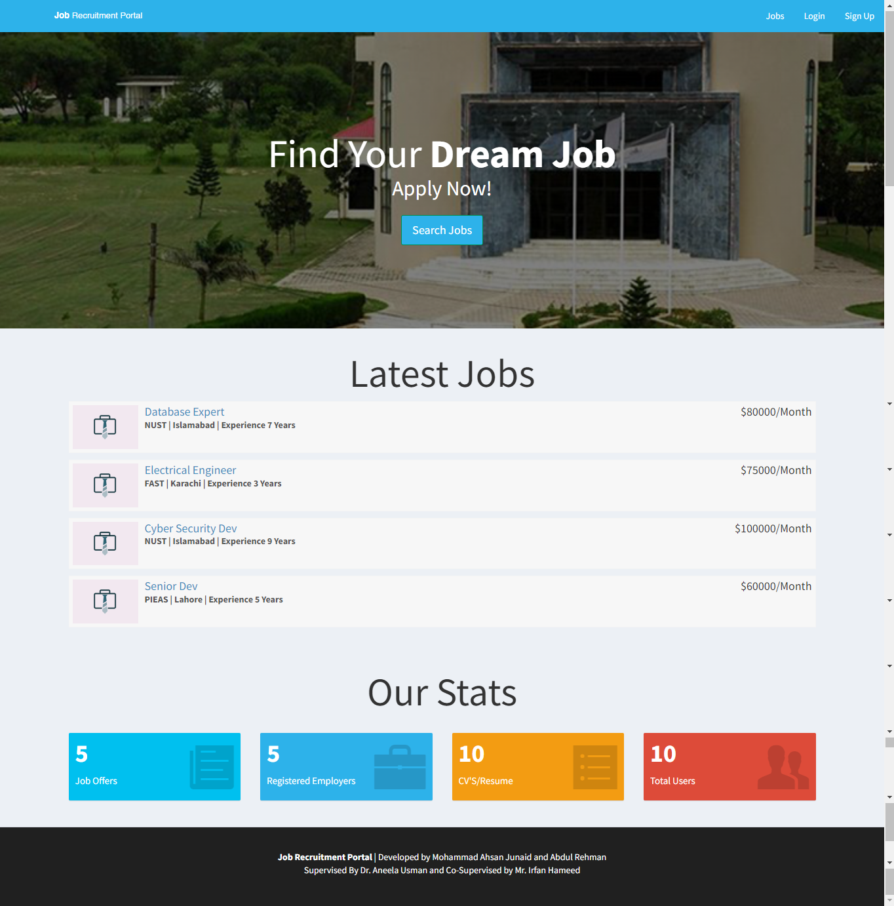

Figure 4. 1 . Home Page

### Job Posting Page

The following features would be displayed on the page's output:

* Navigation Menu:

Depending on their session status, users can access various website sections such as "Jobs," "Login," "Sign Up," "Dashboard," and "Logout" via a navigation menu that would be visible in the header.

* Search Jobs:

To search for jobs, users can enter a search term and press the button.

* Filters Section:

The page has a section for filters where users can narrow down job listings by "City" and "Experience." Users may refine their search results using the options provided.

* Job Listings:

Based on the entered search terms or selected filters, the page dynamically loads job listings. Users can navigate through multiple pages of the job listings thanks to the pagination feature of the job listings.

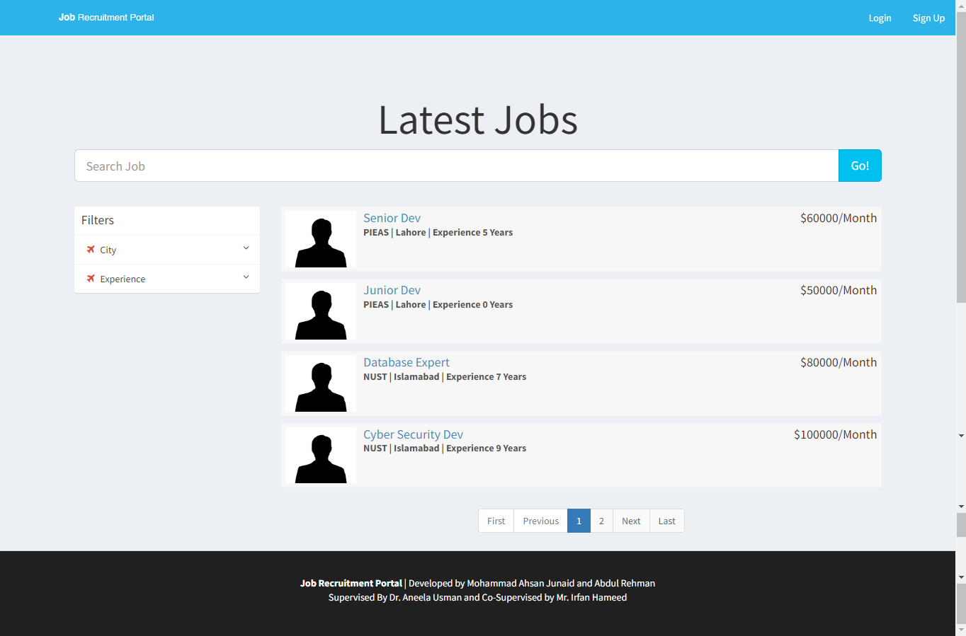

Figure 4. 2. Job Posting Page

### Login Page

The login page is designed to give users a user interface to access the job recruitment portal. There are two ways to log in: "Applicant Login" and "Employer Login." Users can enter their login information and authenticate themselves on this page in order to access their individual dashboards.

* Login Options:

Two login options are shown in the content header section: "Applicant Login" and "Employer Login." Users can access the login pages for employers and applicants by clicking on the corresponding links.

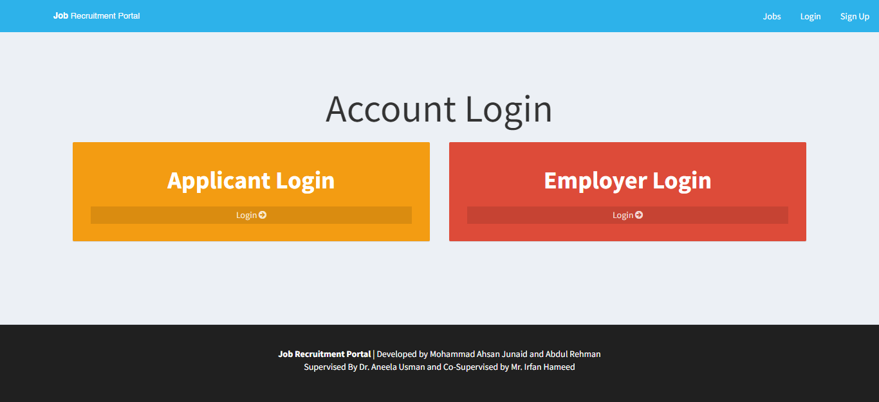

Figure 4.3. Login Page

### Applicant Login Page

The following features would be displayed on the page's output:

* The “Session Check” checks for session variables (such as "$_SESSION['id_user'] or "$_SESSION['id_company']) to see if the user is already logged in. The user is directed to the 'index.php' page if they are already logged in.
* Login Form is where Employers can authenticate themselves by entering their email and password in the login form. The 'action' attribute of the form is set to 'checklogin.php', indicating that the form's data will be sent there for additional processing.
* The form has a link for password recovery if you've forgotten it. The appropriate action should start after clicking the link.

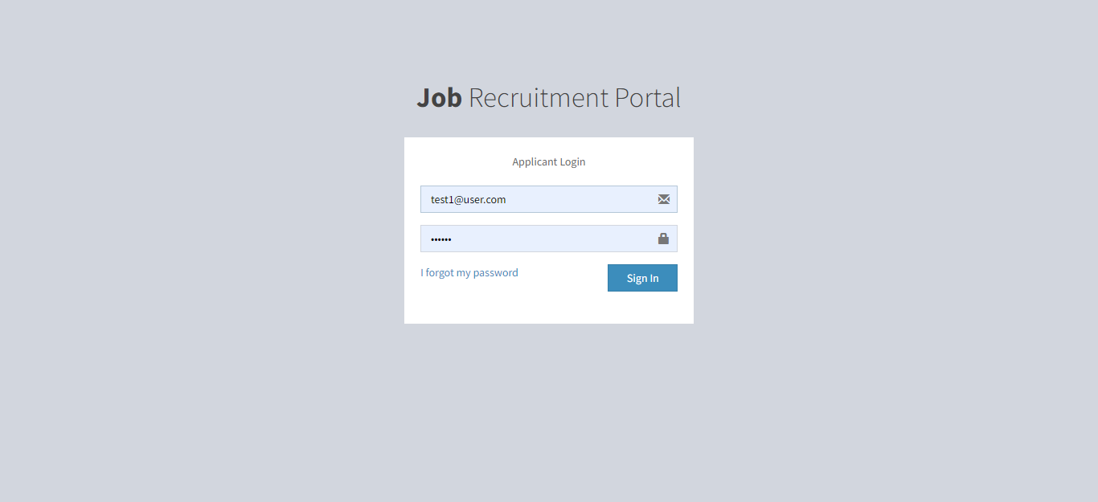

Figure 4.4. Applicant Login

### Employer Login Page

The following features would be displayed on the page's output:

* The “Session Check” checks for session variables (such as "$_SESSION['id_user'] or "$_SESSION['id_company']) to see if the user is already logged in. The user is directed to the 'index.php' page if they are already logged in.
* Login Form is where Employers can authenticate themselves by entering their email and password in the login form. The 'action' attribute of the form is set to 'checklogin.php', indicating that the form's data will be sent there for additional processing.
* The form has a link for password recovery if you've forgotten it. The appropriate action should start after clicking the link.

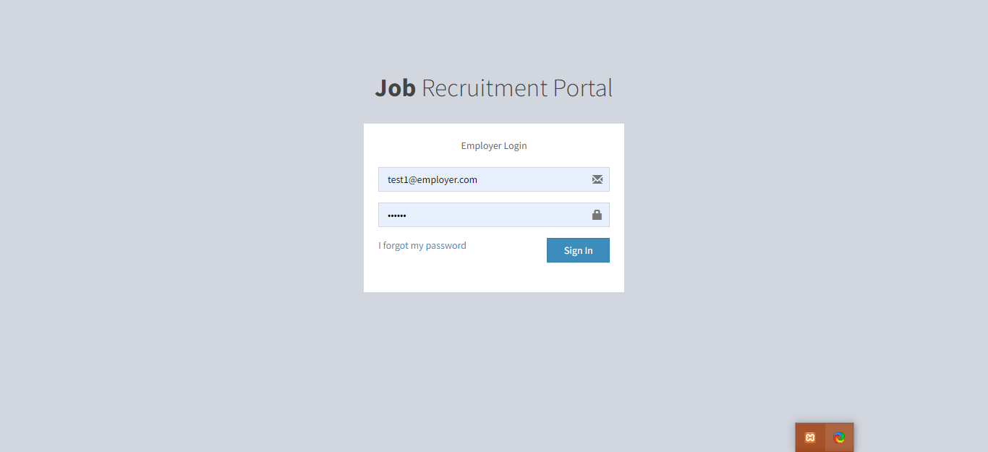

Figure 4.5. Employer Login

### Sign Up Page

The provided code's primary function is to build a sign-up page for a job search engine. The two registration options available to users are "Applicant Registration" and "Employer Registration."

The page aims to make the registration process easier for people who are interested in either posting job listings as employers or applicants. The page offers users a clear and user-friendly interface for choosing their desired path by offering two distinct registration options in aesthetically pleasing boxes.

In general, this page's primary function is to act as a starting point for users to register and interact with the job recruitment portal, depending on whether they want to register as applicants or employers.

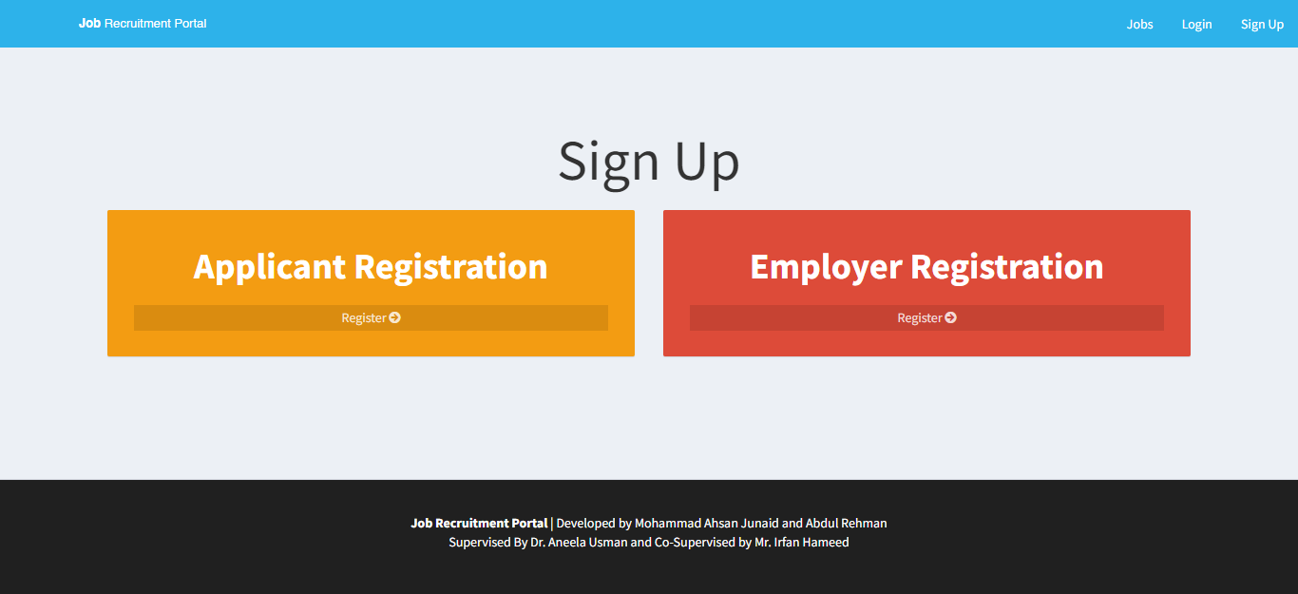

Figure 4.6. Sign Up Page

### Applicant Registration Page

This page's objective is mainly a user sign-up form for applicants. The following are the features and functionalities:

* Users can enter personal information such as their first and last names, email addresses, CNICs (national identification numbers), short bios, dates of birth, ages, and graduation years, as well as their highest educational attainment and stream. Users can also upload their resumes (only in PDF format) and provide contact information.
* For data validation and restrictions, a variety of input fields have attributes like "required," "minlength," "maxlength," and "readonly."
* Dynamic Calculations: The script has JavaScript code that uses the user's selected date of birth to determine their age. The "Age" input field is then automatically updated with the calculated age.

.

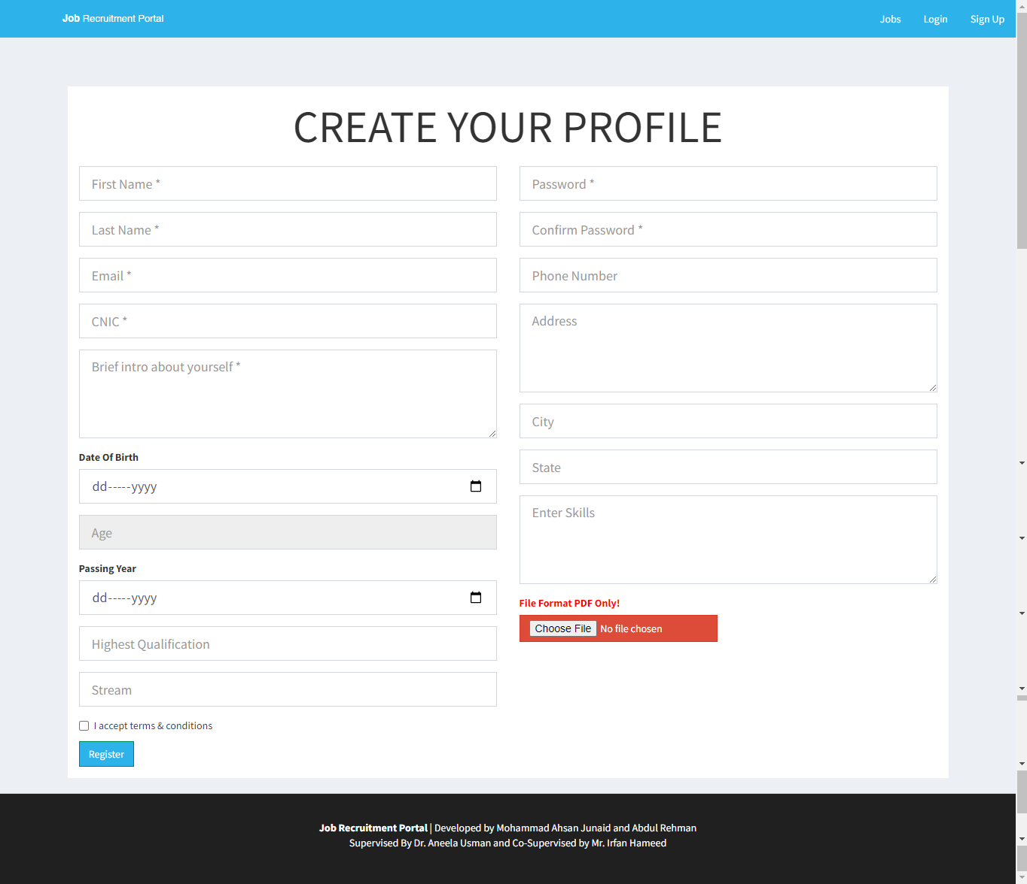

Figure 4.7. Applicant Sign Up

### Employer Registration Page

The following features would be displayed on the page's output:

* Menu for navigating:

Depending on the user's authentication status, the navigation menu has options like "Jobs," "Login," "Sign Up," "Dashboard," and "Logout."

* Form of Registration:

Employers are able to enter information on the form, including their full name, company name, website, email, a brief description of their company, password, a phone number, and the city, state, and country where they are located.

* For data validation and restrictions, different form fields have attributes like required, minlength, maxlength, and autocomplete.

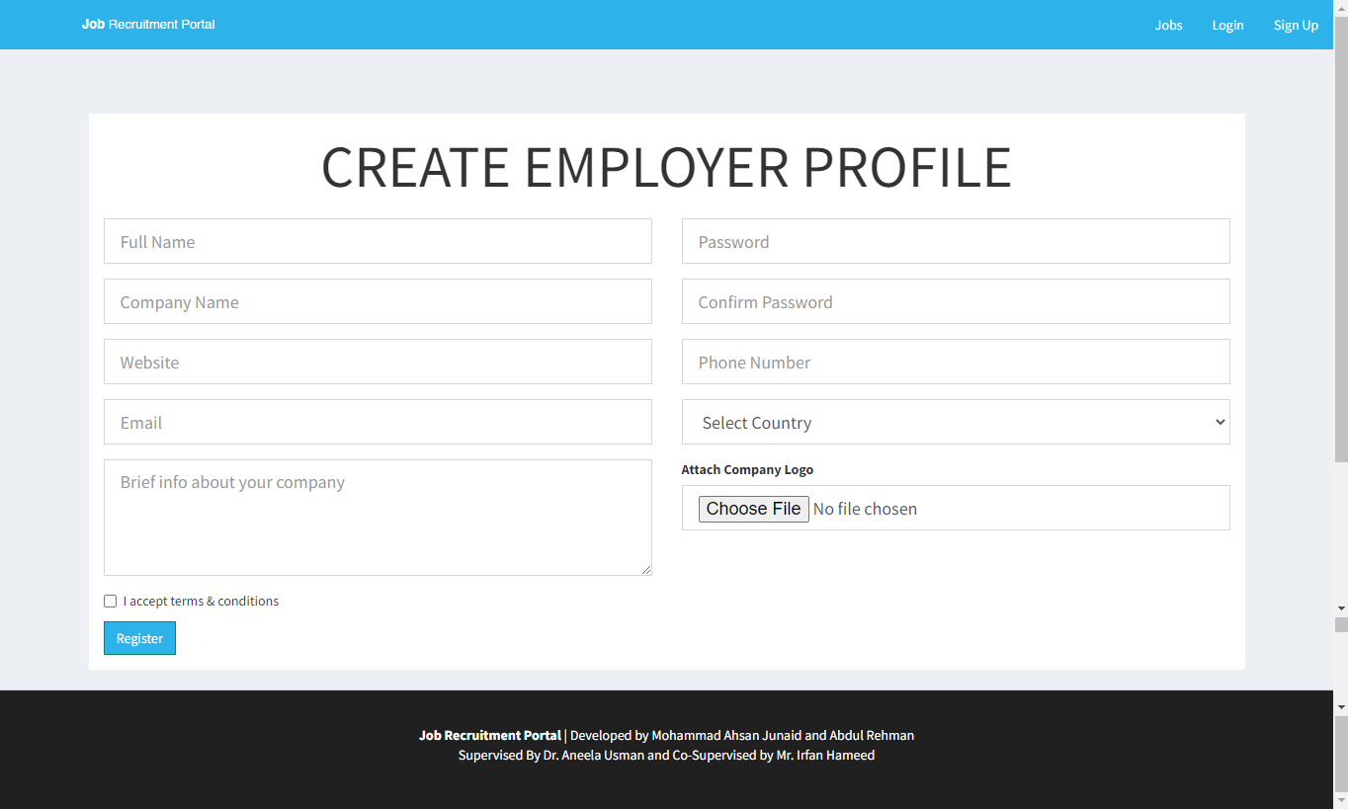

Figure 4.8. Employer Sign Up

### Applicant Dashboard – Edit Profile

Users who are logged in can edit their profile details on this page. The output page's features and capabilities include:

* Display of Profile Information: The user's information is retrieved from the database and shown in the form fields so they can see their current profile information.
* Users can update their profile information, including their first and last names, addresses, cities and states, phone numbers, highest educational qualifications, streams, and skills, as well as the "about me" section. The user's previous data is pre-filled into the form fields, making it simple to make changes.
* Users have the option of uploading or changing their resume file. In order to update their resume for job applications, they can do so.

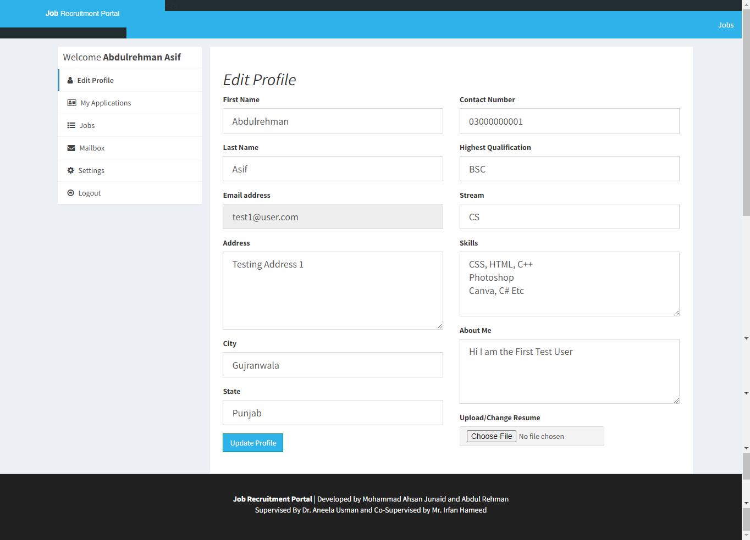

Figure 4.9. Applicant Dashboard

### 4.2.10. Applicant Dashboard – Job Applications

The following features would be displayed on the page's output:

* The page has a header section with a navigation menu and a logo. Users can access various website sections, including the list of vacant positions, using the navigation menu.
* The user's name and links to several profile-related actions, such as editing their profile, accessing their mailbox, and changing settings, are displayed in the sidebar on the left side of the page.
* A list of the user's most recent job applications is displayed in the page's main content area. The job title, application date, and application status are all displayed for each application. A detailed view of the job posting can be accessed by clicking the job title and details are shown further on.

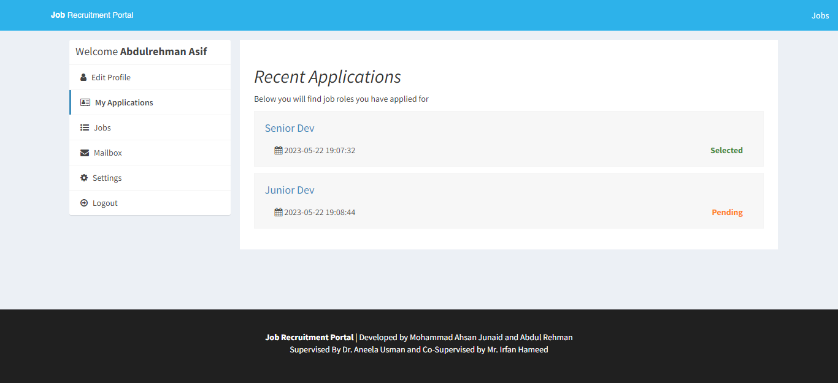

Figure 4.10. Applicant Dashboard

### 4.2.11. Applicant Dashboard – Mailbox

The following features would be displayed on the page's output:

* The "Mailbox" section is the page's primary content. For the logged-in user, it shows a list of messages that have been received and sent. Each message's subject and date are displayed on screen. The user can access the entire message's content by clicking the link in the subject.
* The "Create" button, which enables users to write new messages.
* Navigation has links to the portal's various sections, including "Jobs."
* Features a list of choices for the user who is logged in in the sidebar. There are several options available, including "Edit Profile," "My Applications," "Jobs," "Mailbox," "Settings," and "Logout." This makes it simple to access the portal's various features.

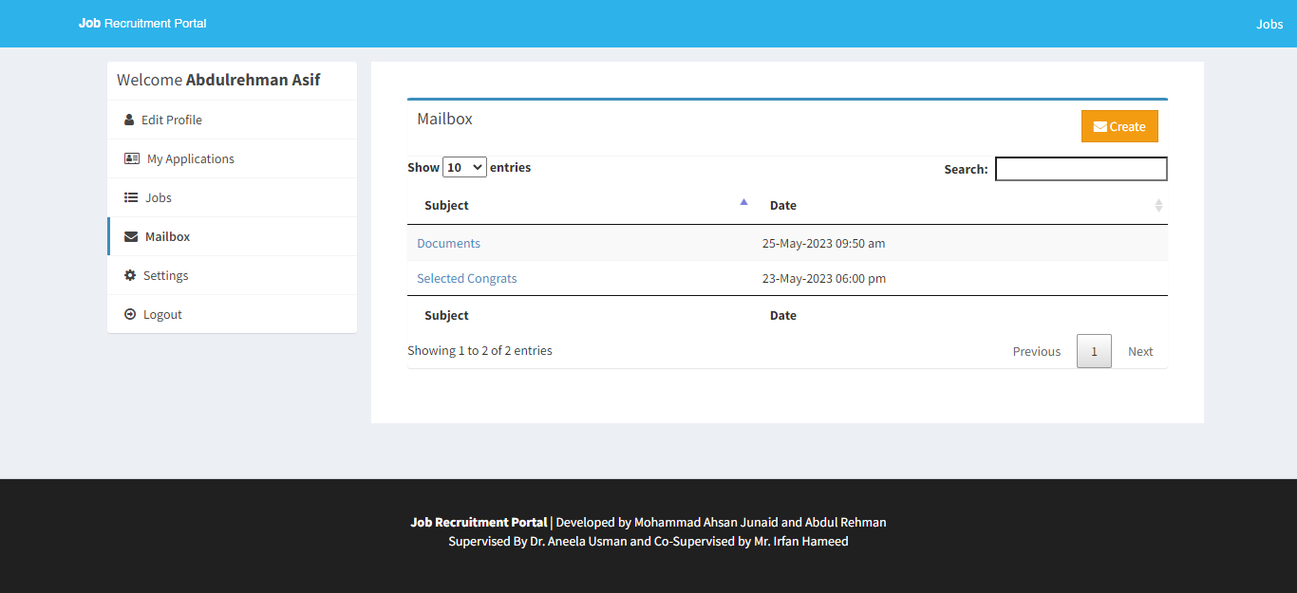

Figure 4.11. Applicant Dashboard

### 4.2.12. Applicant Dashboard – Read / Reply Mail

The following features would be displayed on the page's output:

* Form for Writing a New Message:

On the output page, there is a form for writing a new message. The form has sections for writing the message body, selecting the recipient from a list of companies, and entering the subject. It has fields for choosing the recipient, writing the message body, and choosing a subject.

* Menu of Options:

A menu of options is visible on the output page, including "Edit Profile," "My Applications," "Mailbox," "Settings," and "Logout." These choices enable users to carry out a variety of tasks within the portal.

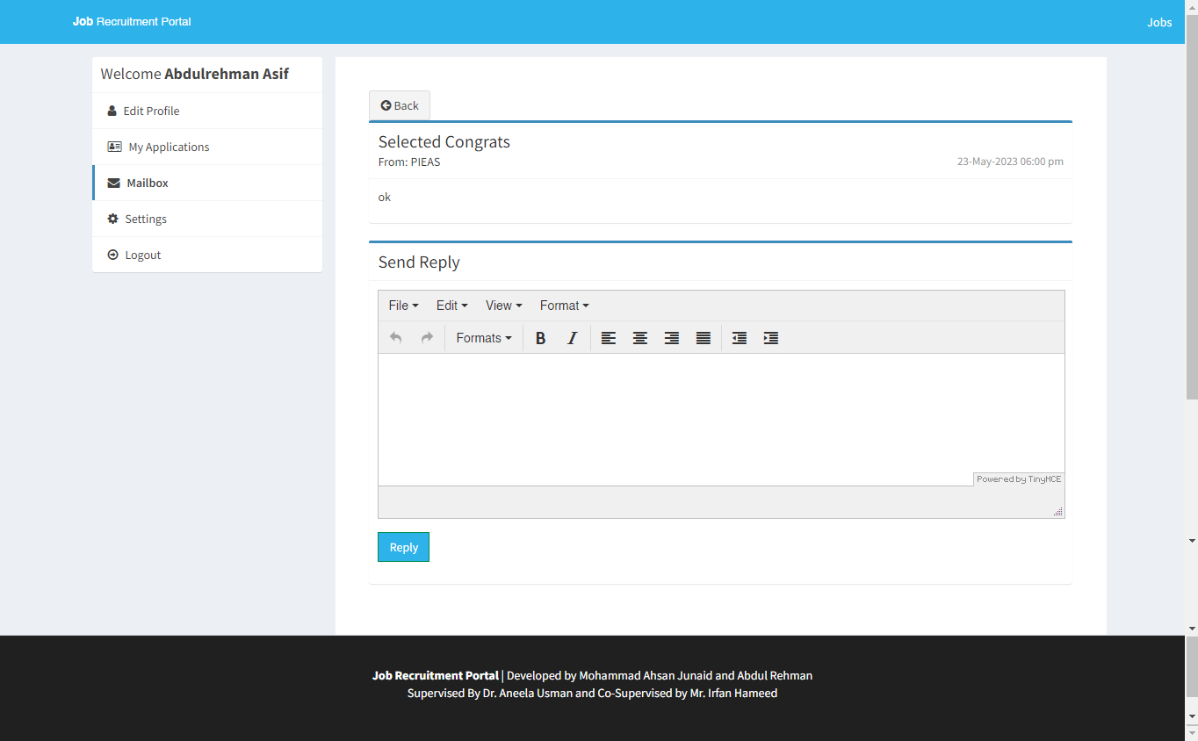

Figure 4.12. Applicant Dashboard

### 4.2.13. Applicant Dashboard – Settings

The following features would be displayed on the setting page's output:

* Change Password Form:

It has a form to change the user's password is located, it has two input fields where new password is entered and confirmed. There is a submit button given with it “Change Password." Which is pressed to save the new password. The password and confirm password entries must be matching.

* Deactivate Account Form:

We can also deactivate a user's account, It has a checkbox to confirm the user wants to deactivate his/her account and a "Deactivate My Account" submit button.

* The page has a navigation bar at the top that users can use to access the different website sections. In this instance, a link to "Jobs" is available.

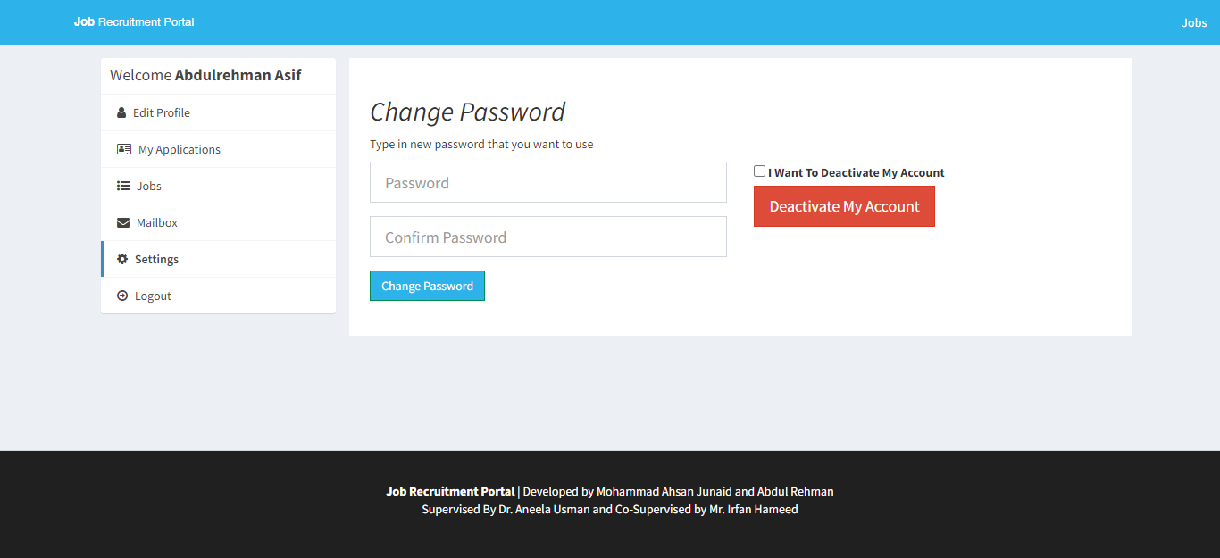

Figure 4.13. Applicant Dashboard

### 4.2.14. Employer Dashboard

The following features would be displayed on the page's output:

* Overview Section:

The overview section of the page's main content area includes a brief overview of the dashboard. It also has an information icon and an alert message.

* Information Boxes:

There are two information boxes below the overview section. The number of job postings created by the user's company is shown in the first box. The quantity of job applications for the company's open positions is displayed in the second box. Using SQL queries, the data in these boxes is retrieved from the database.

* User Profile Sidebar:

There is a sidebar on the left side of the page that features the name of the currently logged-in user and links to various account sections.

In general, the output page acts as a dashboard for users of the job recruitment portal who are logged in. It gives users a quick look at their account information, gives them access to different sections, and lets them take actions regarding their business, job postings, job applications, mailbox, and settings.

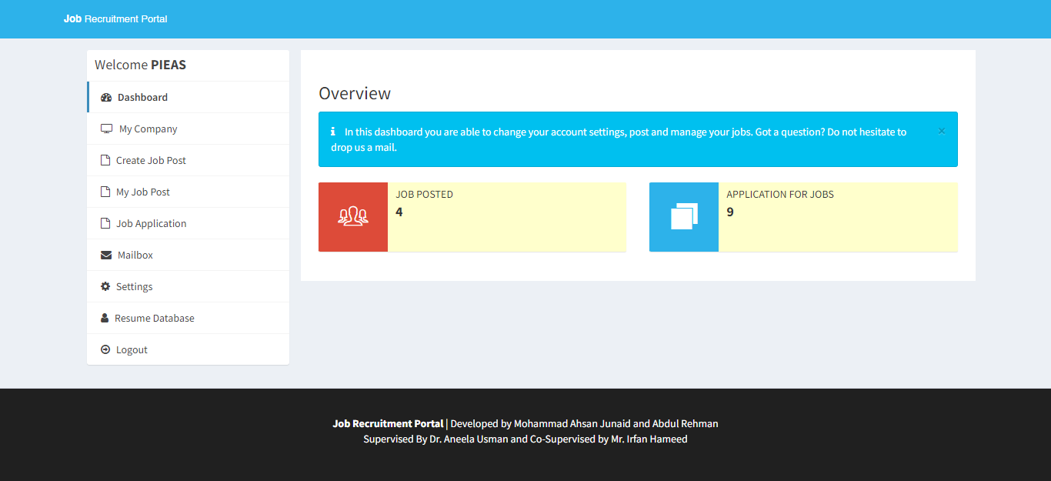

Figure 4.14. Employer Dashboard

### 4.2.15. Employer Dashboard – Company Details Page

The following features would be displayed on the page's output:

* It includes a form for updating company information.
* Company name, website, email, about me, phone number, city, and state are among the fields on the form.
* The form fields have already been filled in with the user's current company information.
* By choosing a file, the user can update the company logo.
* The form is displayed along with the user's uploaded logo, if any.
* An error message is shown below the form if there is a problem with the file upload process.
* Sidebar: The sidebar offers the user a menu with various options.

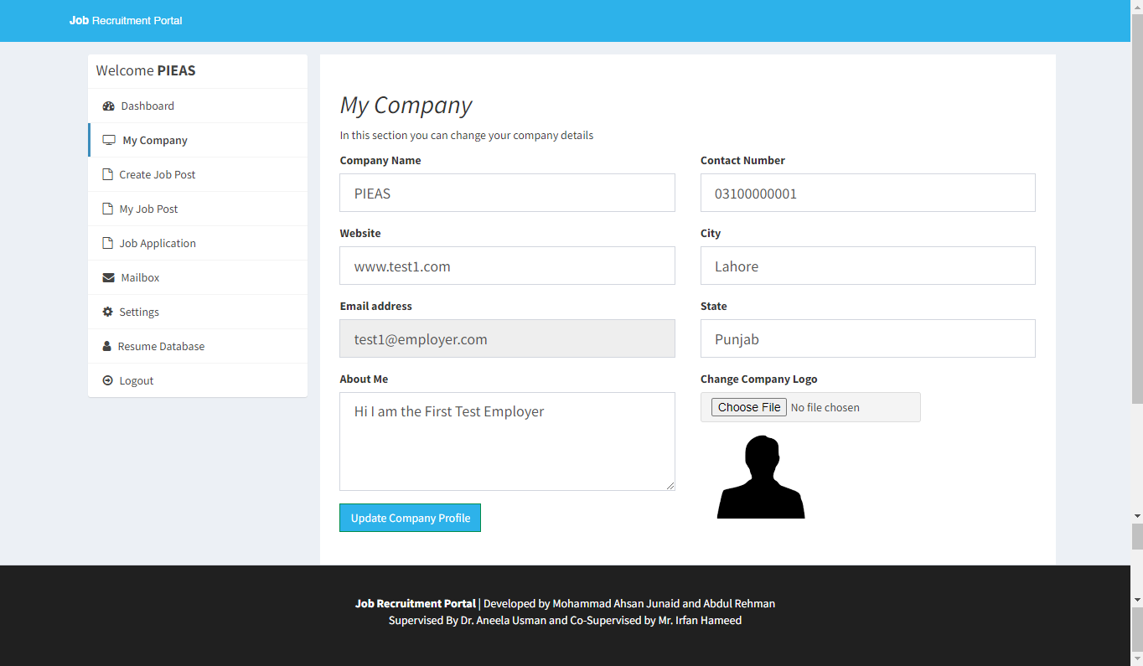

Figure 4.15. Employer Dashboard

### 4.2.16. Employer Dashboard – Create Job Page

The following features would be displayed on the page's output:

* Job description, minimum and maximum salaries, experience and education requirements, and the required maximum age are among the form's fields.
* The user can fill out the relevant form fields with the information for the job posting.
* The information is sent for processing after the form has been submitted. A form for creating a new job posting is included.
* The form's fields for the job title, job description, minimum and maximum salaries, experience and education requirements, and the required maximum age are all included.

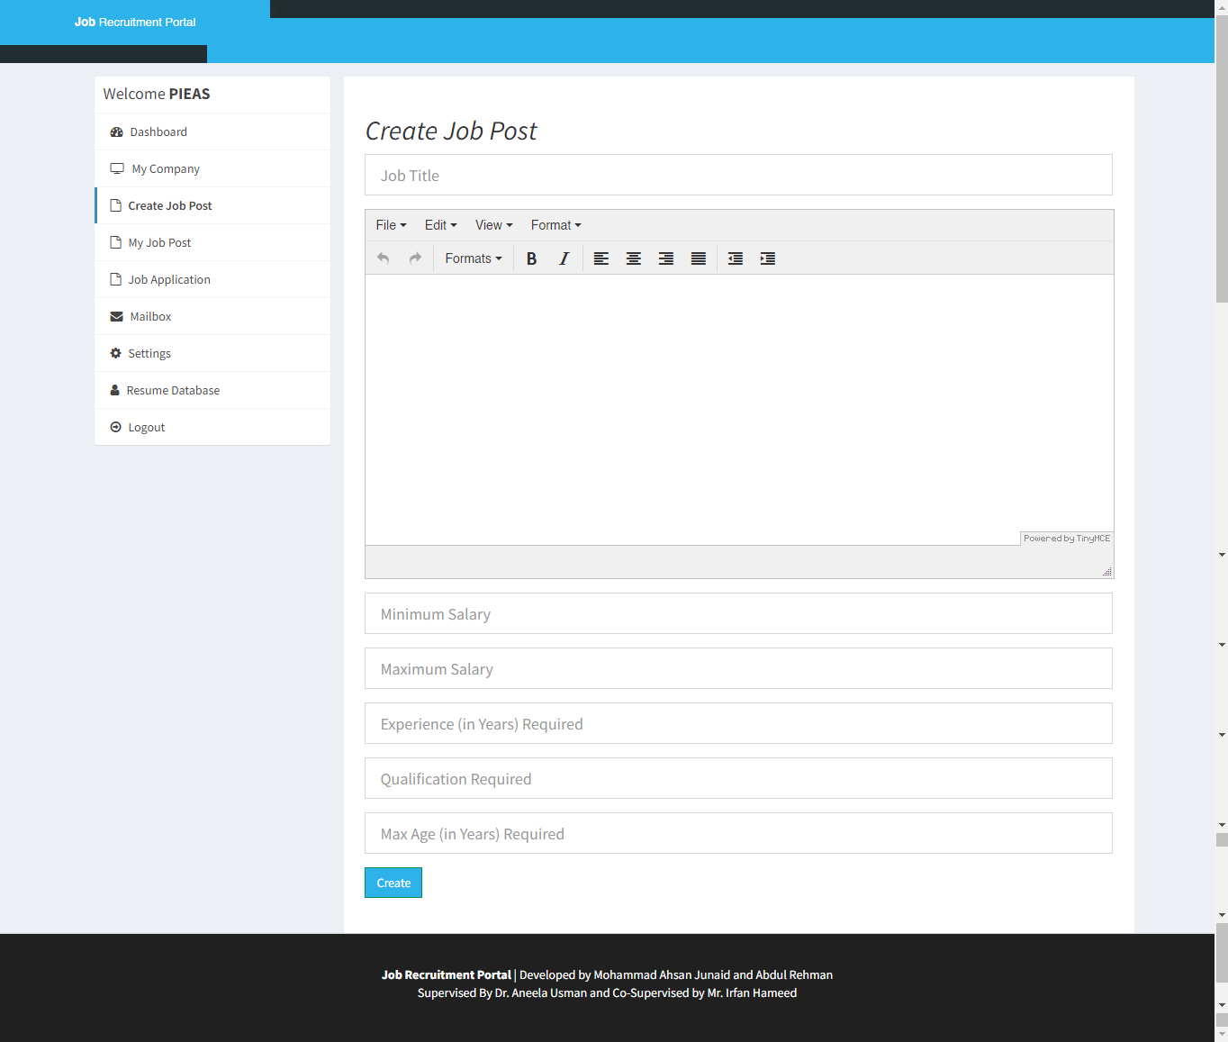

Figure 4.16. Employer Dashboard

### 4.2.17. Employer Dashboard – Posted Jobs

The following features would be displayed on the page's output:

* This shows a table of the user-created job postings.
* Each job post's title is listed in the table, along with a link to view more information.
* Based on the user's company ID, the database's job postings are retrieved.
* The table includes any open positions if there are any.

Generally speaking, the page offers employers a user-friendly interface for viewing and managing their job posts in the job recruitment portal. In order to retrieve and present pertinent information, it provides navigation, data presentation, and integration with a backend database.

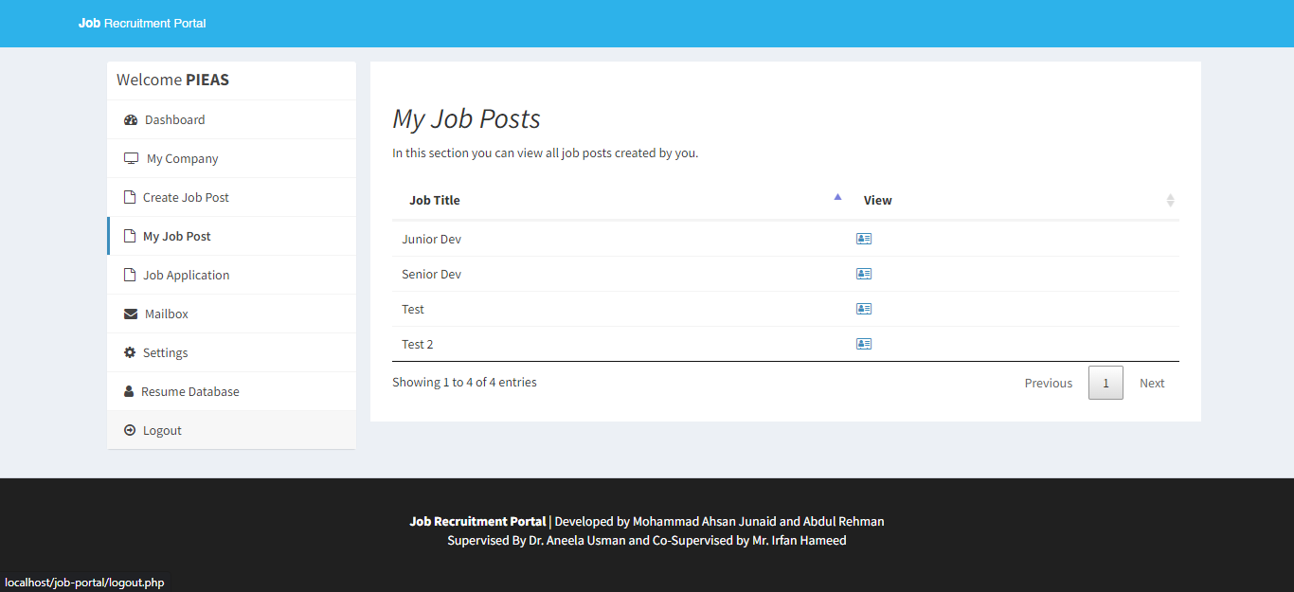

Figure 4.17. Employer Dashboard

### 4.2.18. Employer Dashboard – Job Applications Page

The following features would be displayed on the page's output:

* Recent Applications:

The page fetches data from the database about job applications submitted by users. It retrieves the job title, applicant name, application date, and status for each application.

* Application Status:

The status of each job application is indicated using different colors or text styles. The possible statuses are "Pending," "Rejected," or "Selected."

* Sidebar:

The page has a sidebar on the left side, which displays a list of menu items. Each menu item represents a section of the portal and provides links to navigate to those sections.

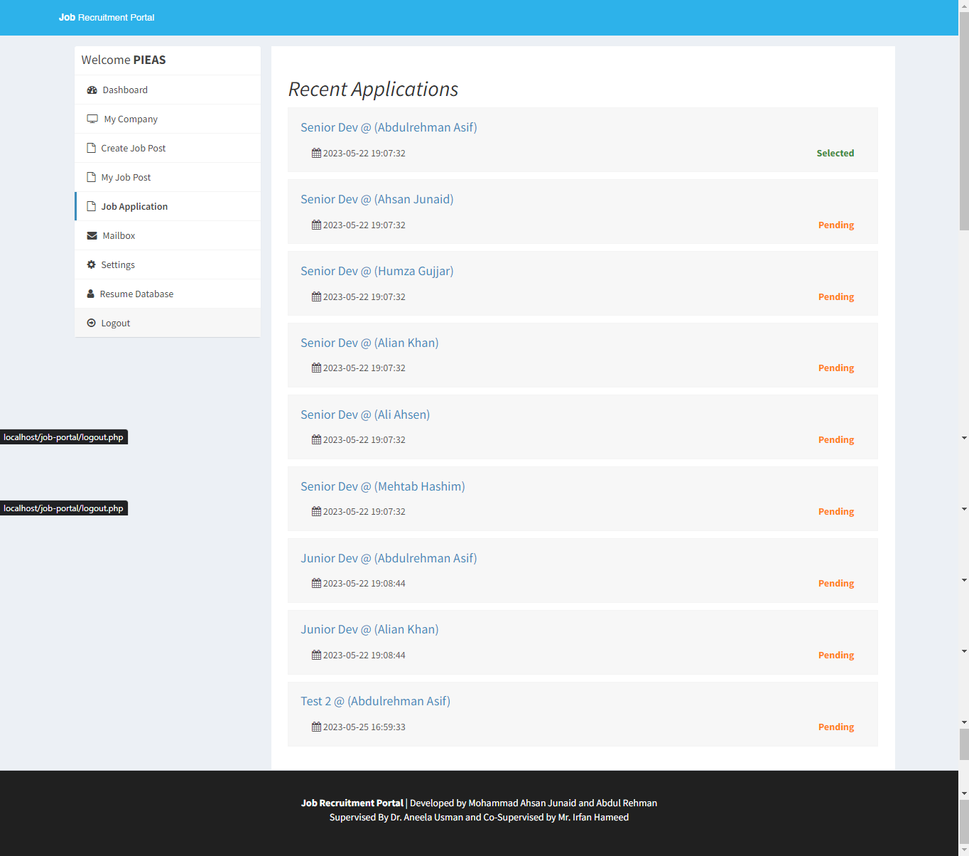

Figure 4.18. Employer Dashboard

### 4.2.19. Employer Dashboard – Mailbox

The following features would be displayed on the page's output:

* Mailbox Section:

The "Mailbox" section is the page's primary content. For the logged-in employers, it shows a list of messages that have been received and sent. Each message's subject and date are displayed on screen. The employer can access the entire message's content by clicking the link in the subject.

* Create New Message:

The "Create" button, which enables users to write new messages. When selected it allows the user to start a new conversation to targeted user.

* Sidebar:

Features a list of choices for the user who is logged in in the sidebar. There are several options available, including "Edit Profile," "My Applications," "Jobs," "Mailbox," "Settings," and "Logout," etc. This makes it simple to access the portal's various features.

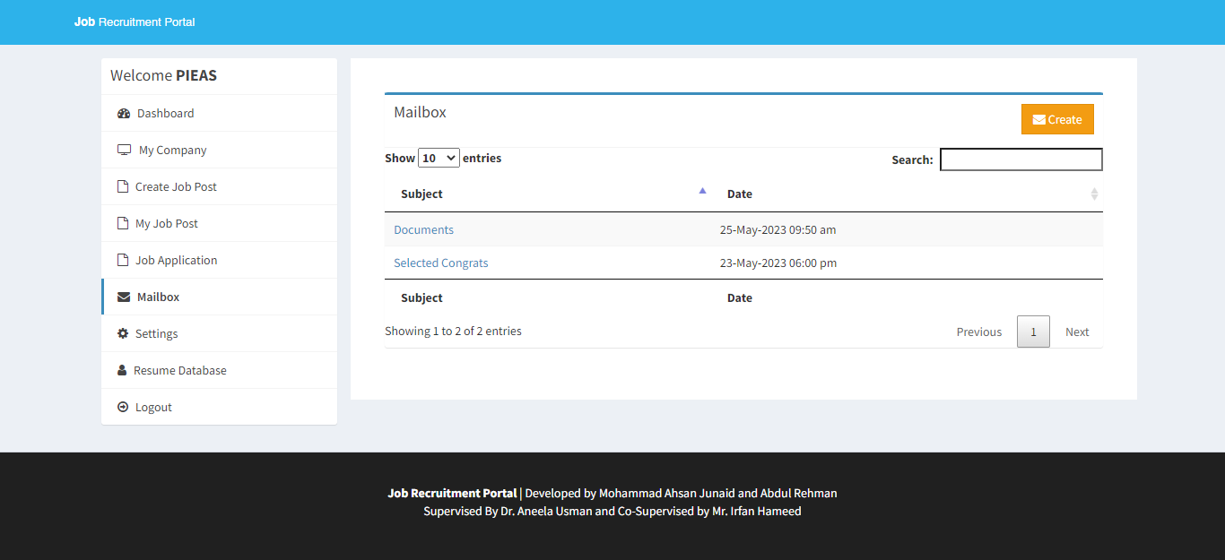

Figure 4.19. Employer Dashboard

### 4.2.20. Employer Dashboard – Reply / Create Mail Page

The following features would be displayed on the page's output:

* Form for Writing a New Message:

A form is shown to the employer to write a message. It has sections for writing like the body, subject of the message, it also has feature of selecting the recipient from a list. It has fields for choosing the recipient, writing the message body, and choosing a subject.

* Menu of Options:

Options are given on the side for the employer to choose which section to go on like "Edit Profile," "My Applications," "Mailbox," "Settings," and "Logout." This enables users navigate within the portal.

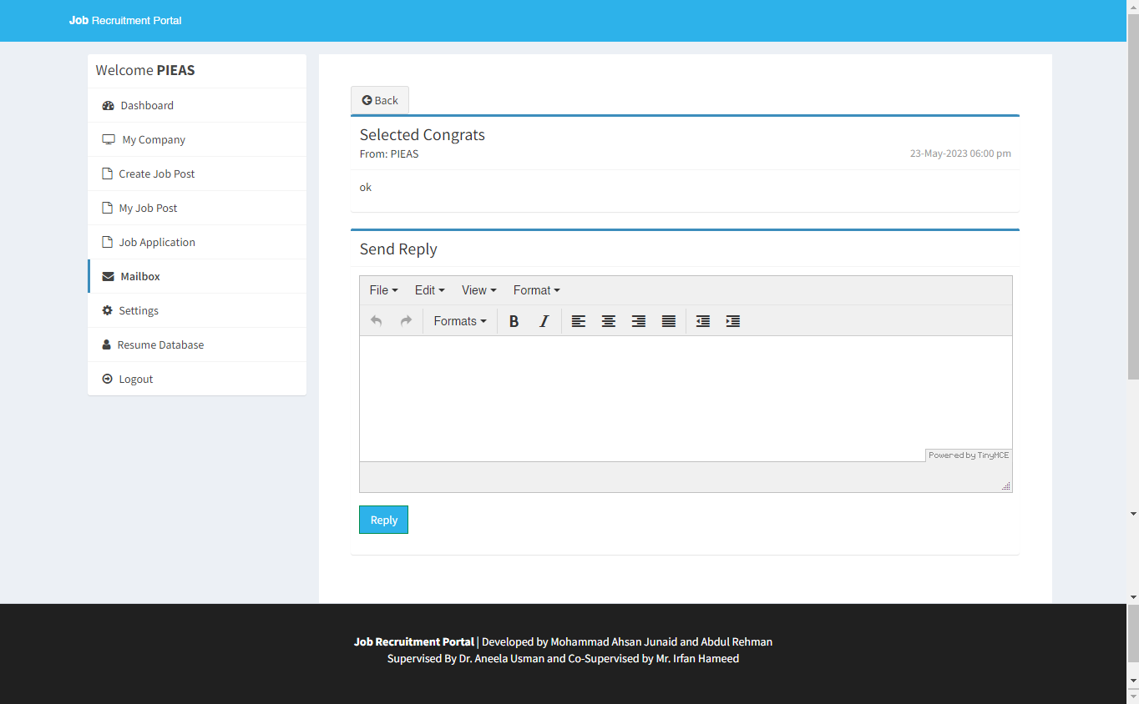

Figure 4.20. Employer Dashboard

### 4.2.21. Employer Dashboard - Settings

The following features would be displayed on the page's output:

* Change Password Form:

The form for changing the employer's password is located in the page's main content area. It has two input fields where the new password can be entered and confirmed. Additionally, there is a submit button marked "Change Password." The password and confirm password fields must match for the form to be valid.

* Change Name Form:

The form for changing the employer's name is located in the page. It has an input field where the name can be entered and confirmed. Additionally, there is a submit button marked "Change Name".

* Deactivate Account Form:

There is a form to deactivate an employer's account. It has a checkbox to confirm the user's desire to deactivate the account and a "Deactivate My Account" submit button.

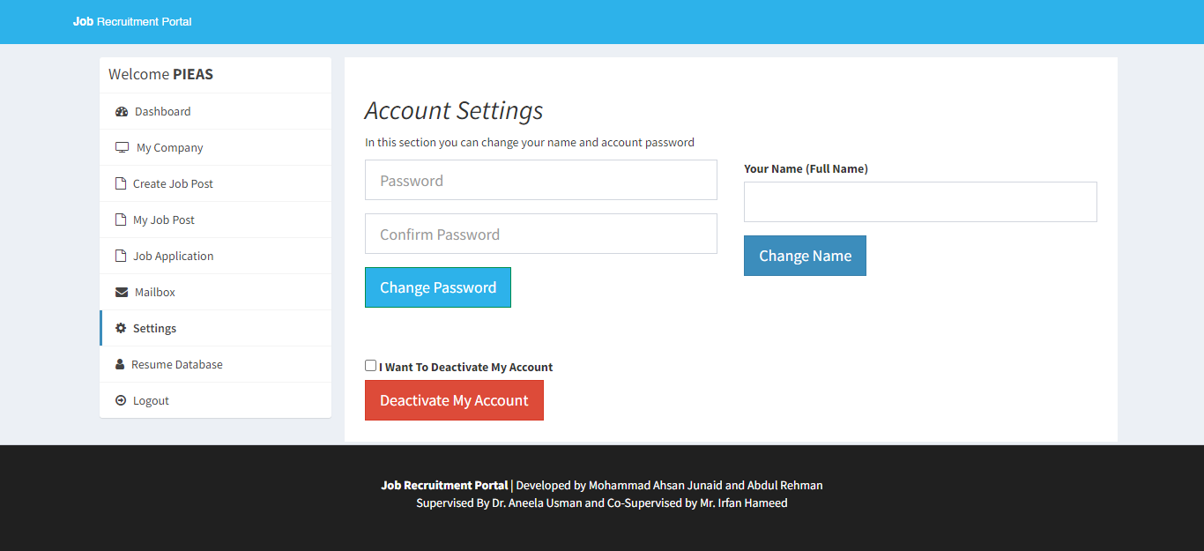

Figure 4.21. Employer Dashboard

### 4.2.22. Employer Dashboard – Applications Database

The following features would be displayed on the page's output:

* The page fetches data from the database about job applications submitted by users. It retrieves the candidate's name, highest qualification, age, city, and state for each application.
* Each row in the table includes a "Download Resume" link that allows the user to download the candidate's resume. The link points to the resume file stored in the "uploads/resume" directory.
* Download CSV is the page that includes a "Download CSV" button that allows the user to download the application data in CSV format. When clicked, the button retrieves the table data, converts it into a CSV string, and triggers a file download.

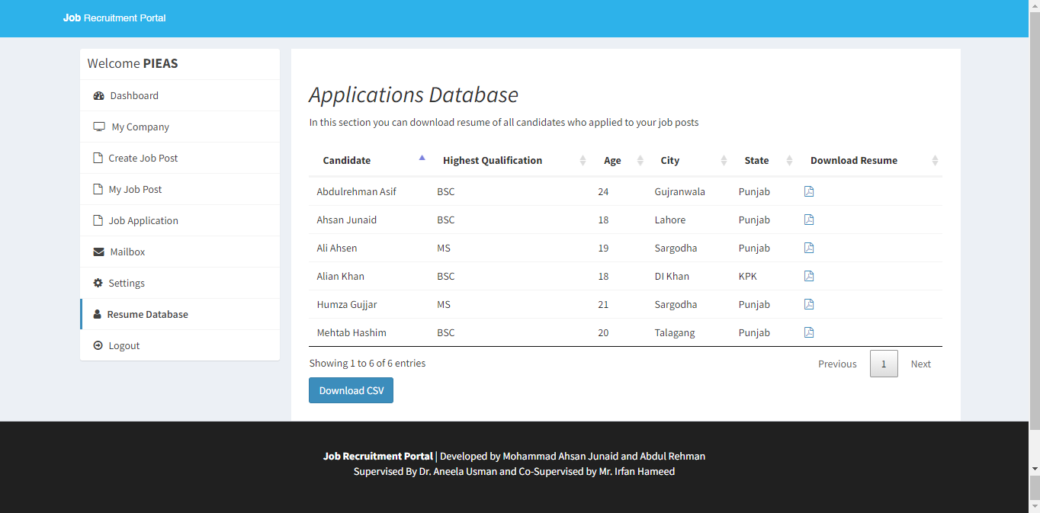

Figure 4.22. Employer Dashboard

### 4.2.23. Admin Dashboard

The following features would be displayed on the page's output:

* The content section of the dashboard displays various statistics related to the job portal, such as the number of active companies, pending company approvals, registered candidates, pending candidate confirmations, total job posts, and total applications.
* Admin dashboard page that displays statistics related to the job portal.
* The sidebar is located on the left side and includes a box with a welcome message and a list of navigation links. The active page is highlighted.

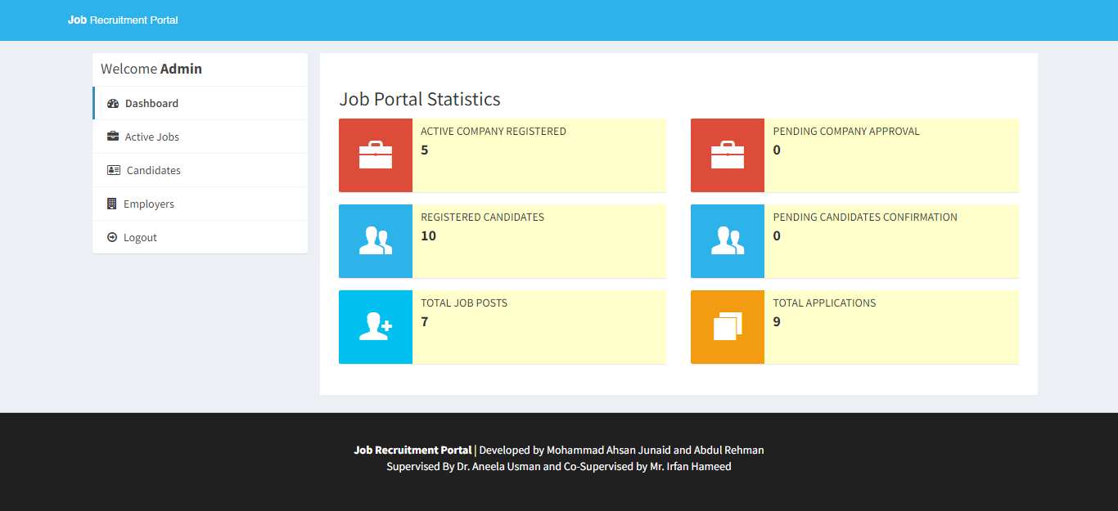

Figure 4.23. Admin Dashboard

### 4.2.24. Admin Dashboard – Active Jobs

The following features would be displayed on the page's output:

* The main content area displays a table of active job posts.
* Each row in the table represents a job post and contains the following information:
* Job Name: The title/name of the job post.
* Company Name: The name of the company associated with the job post.
* Date Created: The date when the job post was created.
* View: An icon/button to view more details about the job post.
* Delete: An icon/button to delete the job post

This page allows the admin user to view and manage active job posts in the portal. Sidebar navigation allows him/her access to different sections, and the job posts table shows an organized view of the available job posts that are posted by employers with title, employer name date created and allows to view and delete it too.

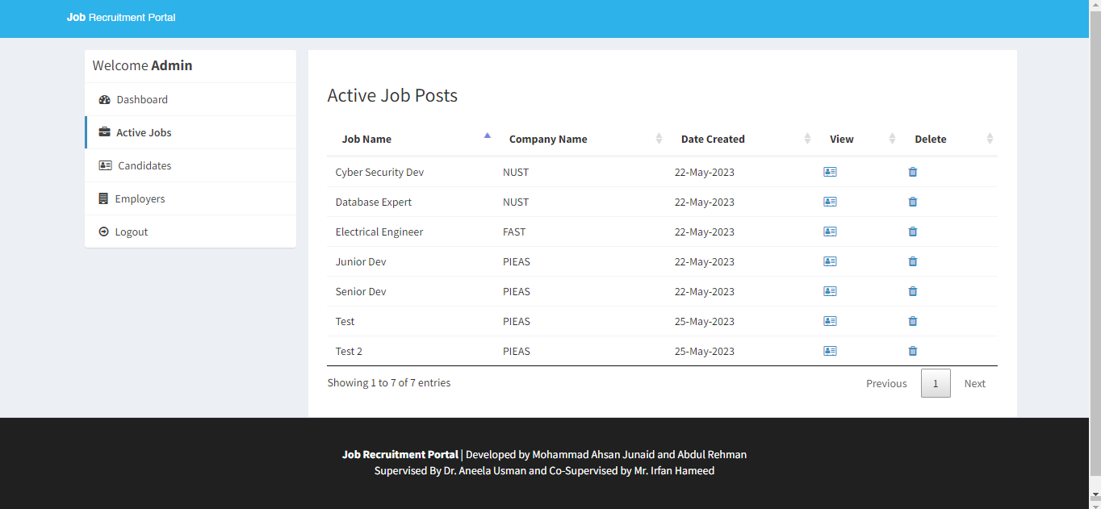

Figure 4.24. Admin Dashboard

### 4.2.25. Admin Dashboard – Applicants Database

It displays a table that lists candidates from a database, providing essential information such as their names, qualifications, skills, location, and resume availability, the following features would be displayed on the page's output:

* Table for Candidate Information: It contains the following columns:
* Candidate: Displays the candidate's full name.
* Highest Qualification: Shows the highest qualification of the candidate.
* Skills: Displays the candidate's skills as labels.
* City: Shows the city where the candidate is located.
* State: Displays the state where the candidate is located.
* Download Resume: Provides a link to download the candidate's resume if available.

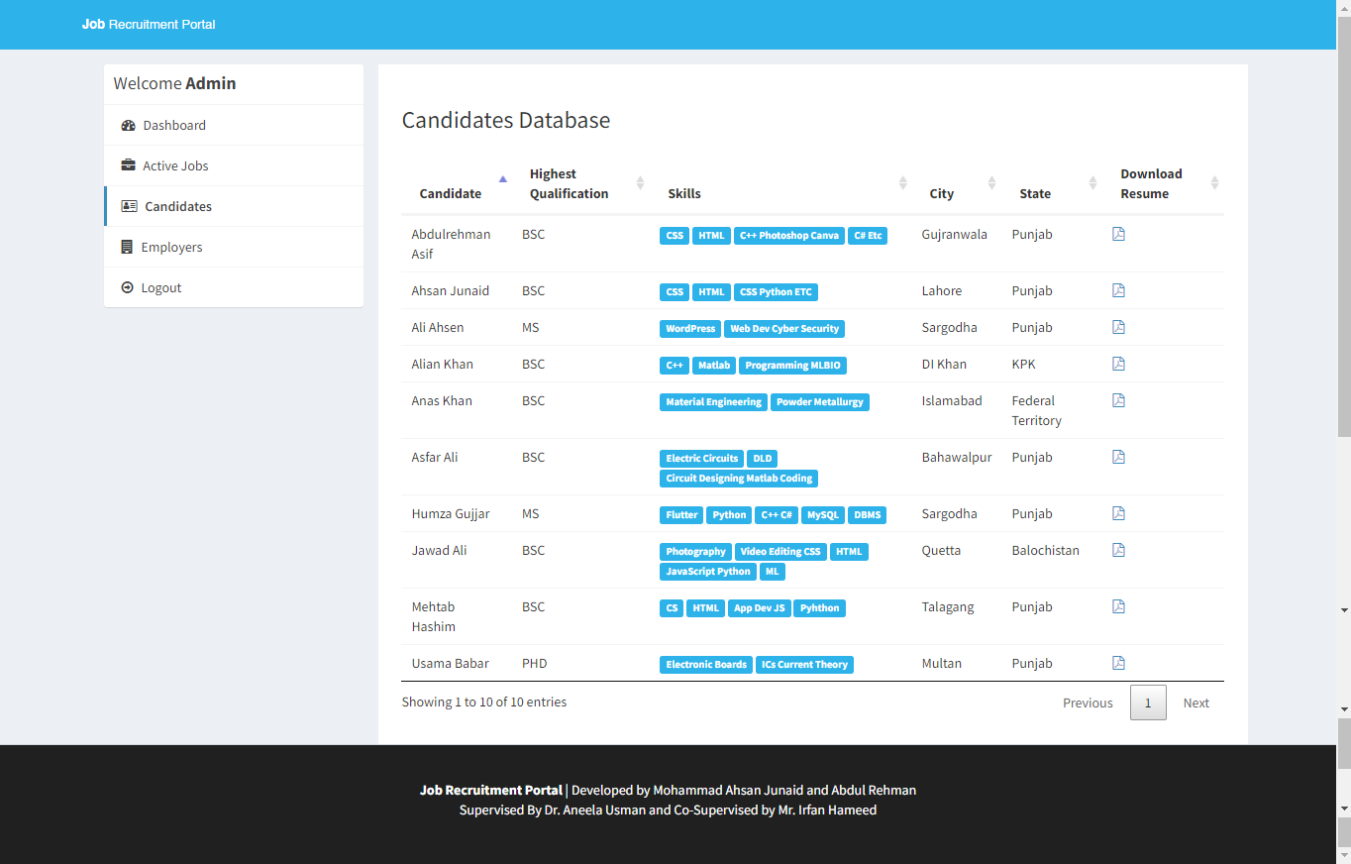

Figure 4.25. Admin Dashboard

### 4.2.26. Admin Dashboard – Employers Database

The page output shows following features:

Status Management:

* The "Status" column in the table shows the status of each employer.
* "Activate" or "Rejected" is shown if the admin choses options to "Reject" or "Approve" the employer/company.

Company Information Table:

The table has following columns:

* Company Name: This column shows the name of the company/employer.
* Account Creator Name: Has the name of the user who created the company's account.
* Email: This column stores the email address.
* Phone: Shows the phone number.
* City: This has the city where the company is located.
* State: It has the state of the company like provinces etc.
* Country: This stores the country where the company is.
* Status: Shows current status of the company, that is "Activated," or "Rejected”.
* Delete: This button allows the admin to delete the company / employer from the database, deleting the user.

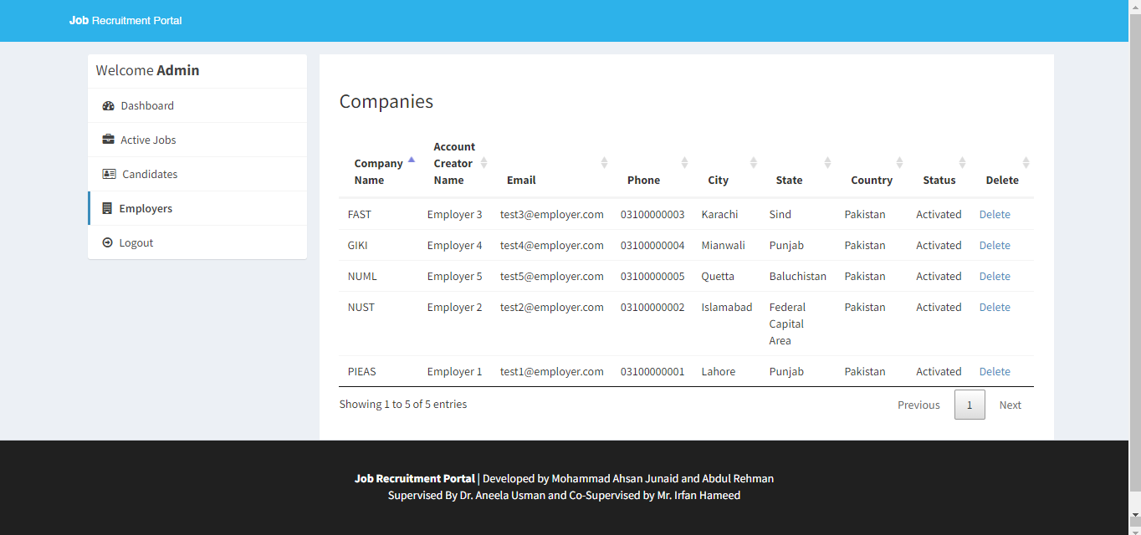

Figure 4.26. Admin Dashboard

## Backend Development

The three main users of the system are the admin, employer and lastly the applicant, here we breakdown their backend part:

### Administrator’s Backend

* + - * Active jobs file shows all the active jobs on the portal
      * Application file shows all the applicant details on the portal
      * Approve company file has code to approve the employer to active the account
      * Companies file has code to show app the employers on the portal
      * Delete company fie has code to delete the employer from the portal
      * Dashboard file has code to display the job portal statistics
      * Reject company file has code to reject the employer’s request to active account on portal
      * Check login file has code to check the username and password to login are correct.

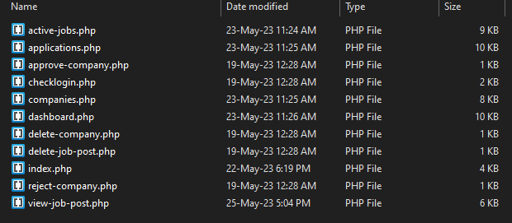

Figure 4.27. Admin Backend

### Employer’s Backend

* Add mail file has code to send mail to the applicant in the mailbox of the portal.
* Add post file has code to post the job details on the portal.
* Change password file has code to change the login password of the employer.
* Deactivate account file has code to delete the employer account.
* Edit- company file has code to edit the profile of the employer.
* Job application file has code to display the responses on the posted job.
* Resume Database file has code to display the details of all applicants who applied for job.
* Settings file has code to change the password of employer or delete the account.
* Update name file has code to change the name of the employer.

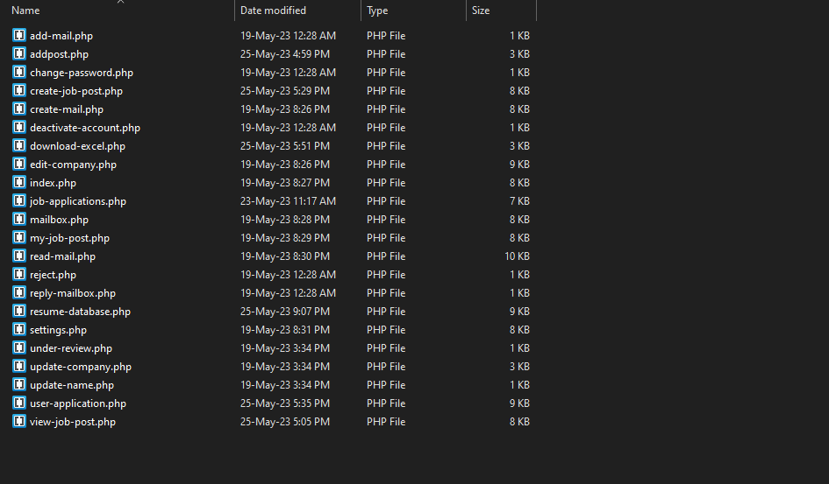

Figure 4.29. Applicant Backend

### User’s Backend

* Add-mail file code is to send mail to the employer.
* Change password file code is to change the password of applicant.
* Deactivate account file code is to delete the account of the applicant.
* Read mail file has code to read the mail from the employer.
* Reply mail file has code to reply the employer.
* Update profile has code to edit the profile of applicant.

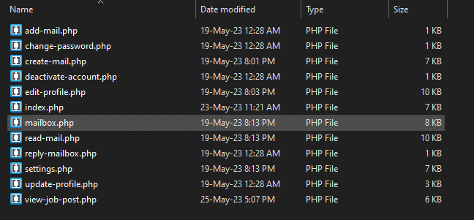

Figure 4.29. User Backend

## 

## Database Structure

The following tables make up the database of the system:

* + - * admin: Keeps track of the admins or system administrators who oversee the job portal.
      * apply_job_post: Tracks applications that job seekers send in for particular job postings.
      * cities: Lists the cities or places that can be connected to user profiles or job postings.
      * company: Saves information of businesses, such as the company ID, name, contact details.
      * countries: Saves a list of nations that can be referred in user profiles or job postings.
      * job_post: Details as job post ID, company ID, job title, description, qualifications.
      * mailbox: Controls user communication, including that between employers and job seekers.
      * reply_mailbox: It has fields like the message ID, the sender ID, the receiver ID, the content.
      * states: Especially in countries with subdivisions, this section contains a list of states or regions that can be connected to job postings or user profiles.
      * users: Saves user data, like user ID, name, email, password, and contact information so on.

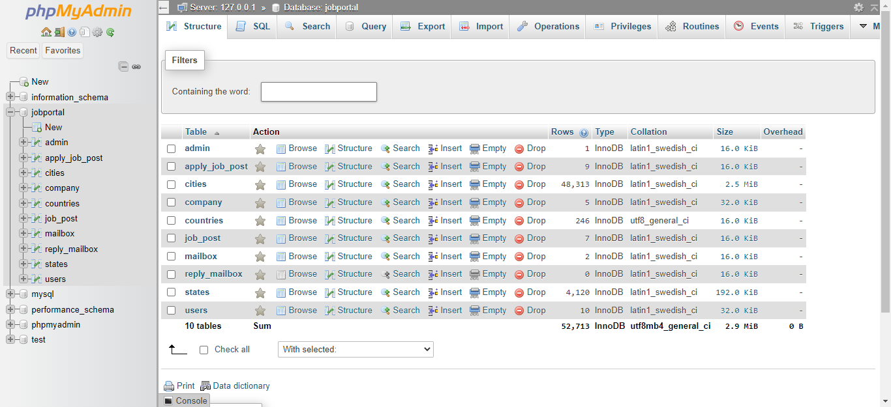

Figure 4.30. Database

### Admin Table

Description of each column in the table:

* + - * id_admin: It represents the unique identifier for each admin in the table.
      * username: It stores the username or login name of the admin.
      * password: It stores the encrypted password associated with the admin's account.

These columns store the essential information related to the admin accounts in the table, allowing for proper identification and authentication of administrators within the system.

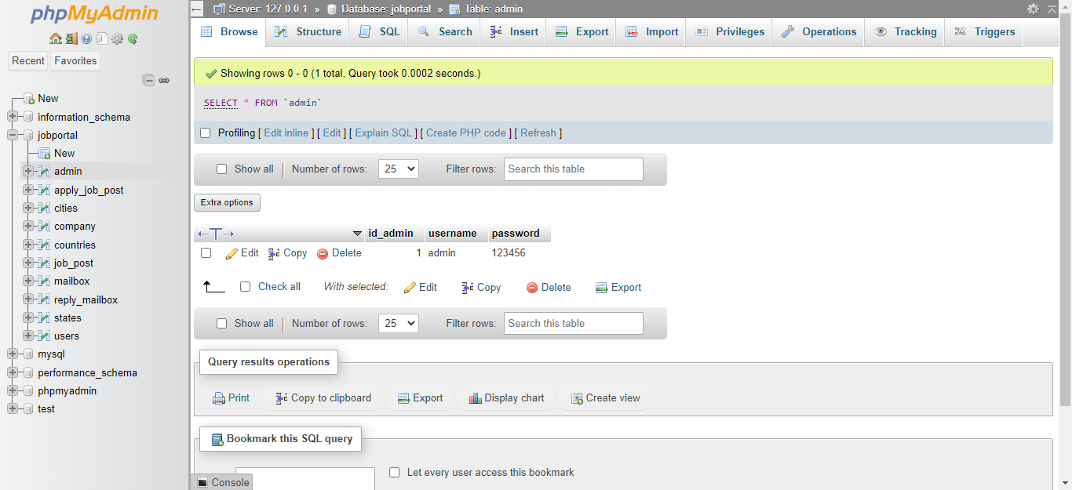

Figure 4.31. Admin Table

### Apply_Job Table

Description of each column in the table:

* + - * id_apply: It represents the unique identifier for each job application in the table.
      * id_jobpost: It stores the identifier of the job post to which the application is made.
      * id_company: It stores the identifier of the company associated with the job post.
      * id_user: It stores the identifier of the user or candidate who submitted the application.
      * status: It represents the status of the job application, approved, rejected etc.

These columns are used to manage and track job applications, associating them with specific job posts, companies, and users, and keeping track of their status throughout the application process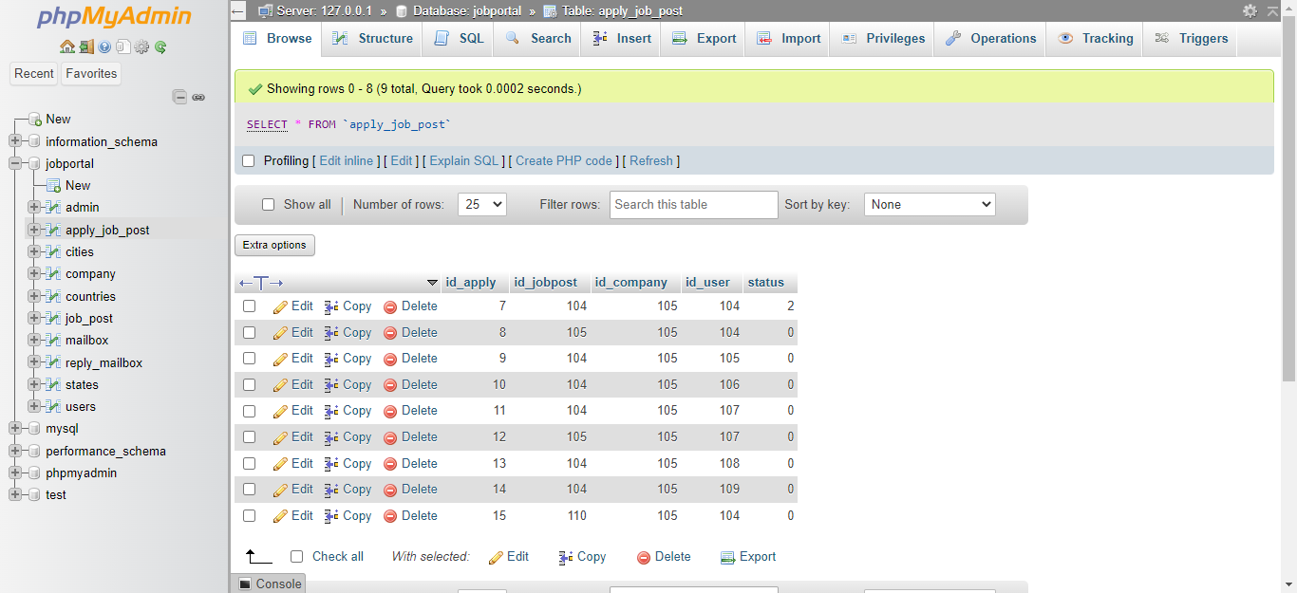

Figure 4.32. Apply Job Table

### Cities Table

The table "cities" represents a collection of cities. Here's a brief description of each column:

* id: It is a unique identifier for each city in the table.
* name: It stores the name of the city.
* state_id: It represents the identifier of the state to which the city belongs.

The "cities" table allows for the storage and retrieval of city-related data.

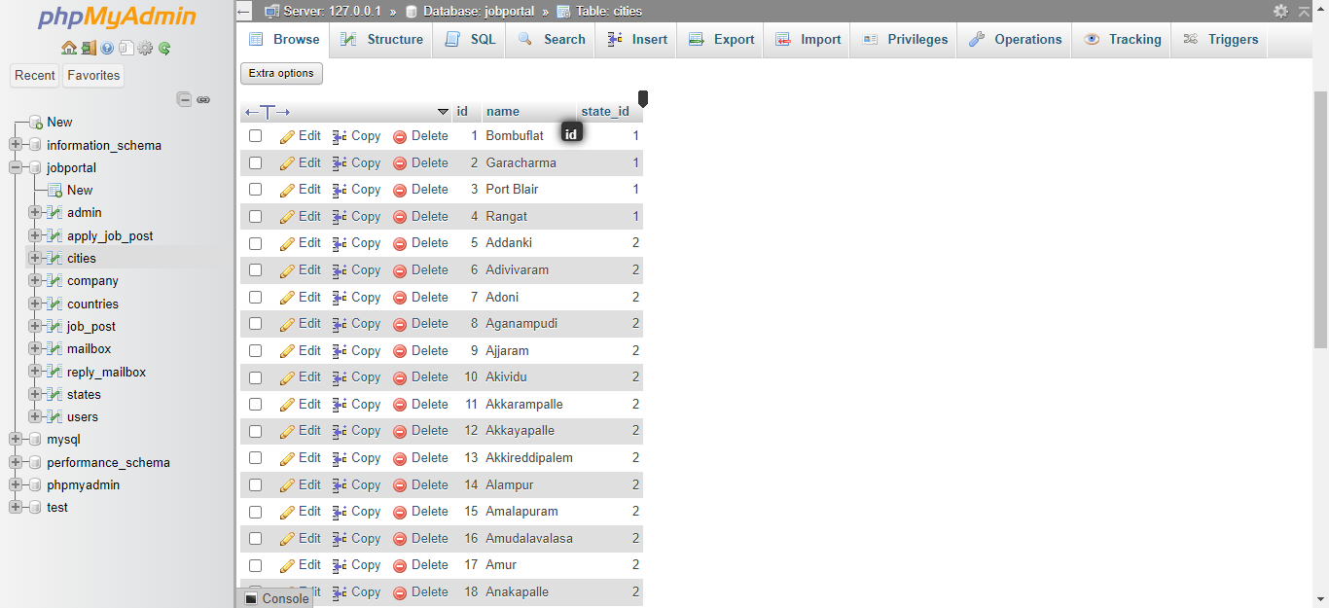

Figure 4.33. Cities Table

### Companies Table

The table "id_company" represents a collection of employers. Description of each column:

* id_company: It is a unique identifier for each company in the table.
* name: Stores name of the contact person associated with the company.
* companyname: It represents the name of the company.
* country: It stores the country where the company is located.
* state: It represents the state or province where the company is located.
* city: It stores the city where the company is located.
* contactno: It stores the phone number associated with the company.
* website: It represents the website URL of the company.
* email: It stores the email address associated with the company.
* password: It stores the password for the company's account.
* aboutme: It provides a description or information about the company.
* logo: It stores the file or path of the company's logo.
* createdAt: It indicates the date and time when the company's account was created.
* active: It represents the status of the company's account (e.g., activated, rejected etc.).

The "id_company" table allows for the storage and management of company-related information. It can be used in a job recruitment portal to store details about employers, their contact information, and the status of their accounts.

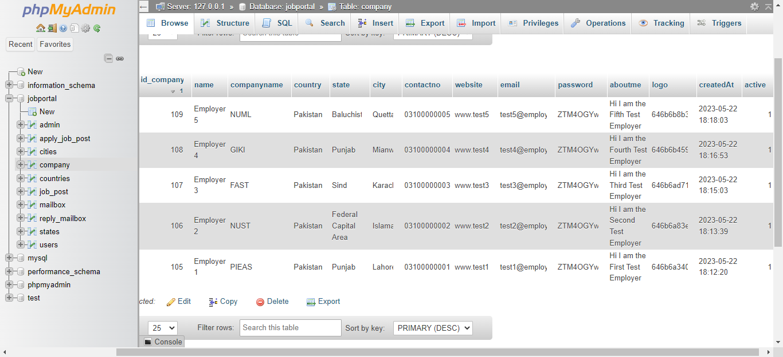

Figure 4.34. Companies Table

### Countries Table

The table "country" represents a collection of countries. Here's a brief description of each column:

* id: It is a unique identifier for each country in the table.
* sortname: It stores the abbreviation or short name of the country.
* name: It represents the full name of the country.
* phonecode: Stores the international code or dialing code associated with the country.

The "country" table allows for the storage and retrieval of country-related information. It can be used in various applications or systems where country data is required, such as address forms, user profiles, or international phone number validation.

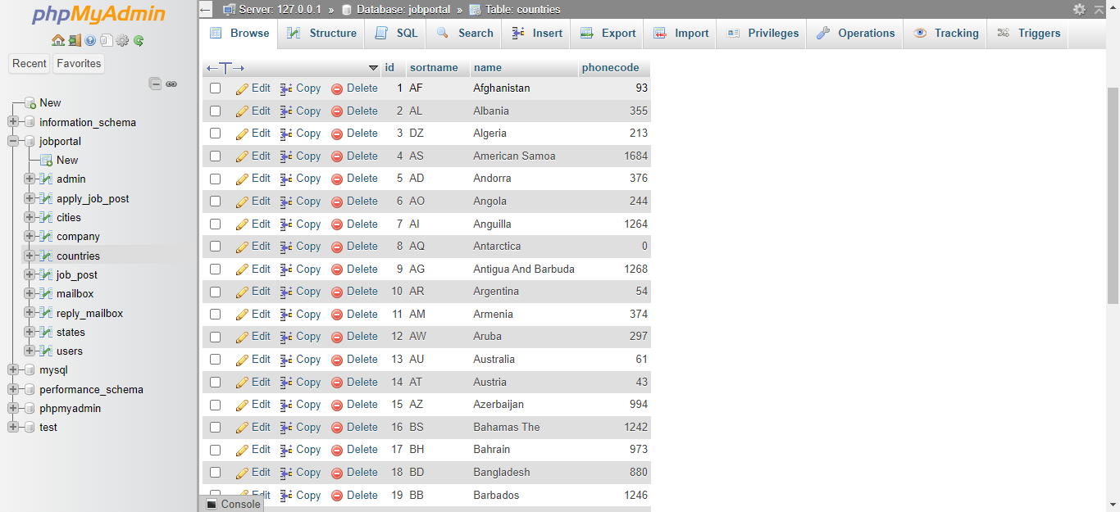

Figure 4.35. Countries Table

### Job Post Table

The table "jobpost" contains information about job postings. Here's a description of each column:

* id_jobpost: It is a unique identifier for each job posting in the table.
* id_company: Represents referencing the id of the company that posted the job.
* jobtitle: It stores the title or name of the job.
* description: It contains the description or details of the job.
* minimumsalary: It specifies the minimum salary or salary range for the job.
* maximumsalary: It represents the maximum salary or salary range for the job.
* experience: It indicates the required experience level or years of experience for the job.
* qualification: Stores the required qualifications or educational requirements for the job.
* createdat: It denotes the timestamp or date when the job posting was created.
* maxage: Represents the maximum age limit or restriction for applicants of the job.

The "jobpost" table allows storing and managing job postings, including their titles, descriptions, requirements, and other relevant details. It facilitates the process of job search and recruitment in a system or application.

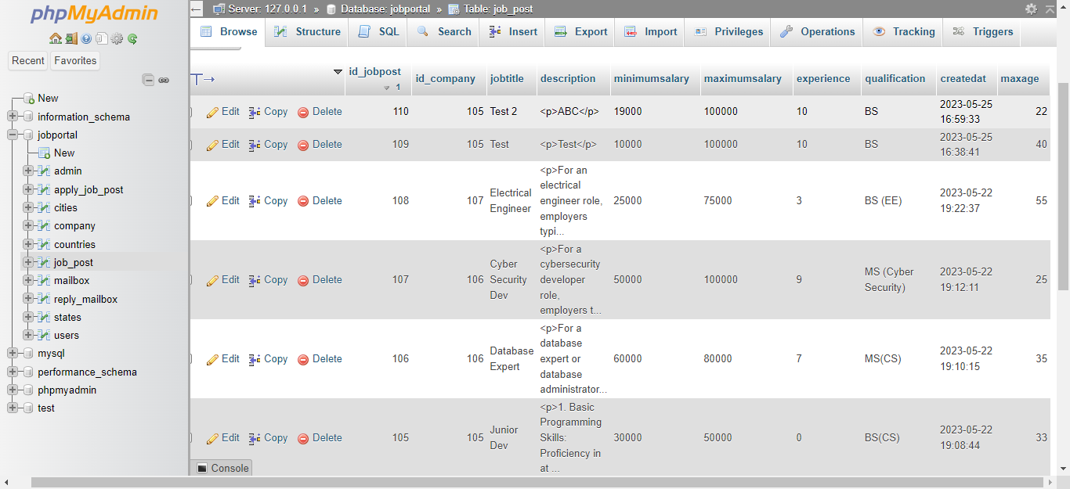

Figure 4.36. Job Post Table

### Mailbox Table

The table "mailbox" contains information related to user messages or emails. Here's a description of each column:

* id_mailbox: It is a unique identifier for each message or email in the table.
* id_fromuser: Represents the referencing the id of the user who sent the message.
* fromuser: It stores the name or username of the user who sent the message.
* id_touser: Represents the referencing of the id of user who received the message.
* subject: It contains the subject or title of the message.
* message: It stores the content or body of the message.
* createdAt: It denotes the timestamp or date when the message was created or sent.

The "mailbox" table allows storing and managing user messages, including the sender, recipient, subject, message content, and creation timestamp. It enables communication and messaging functionality within a system or application.

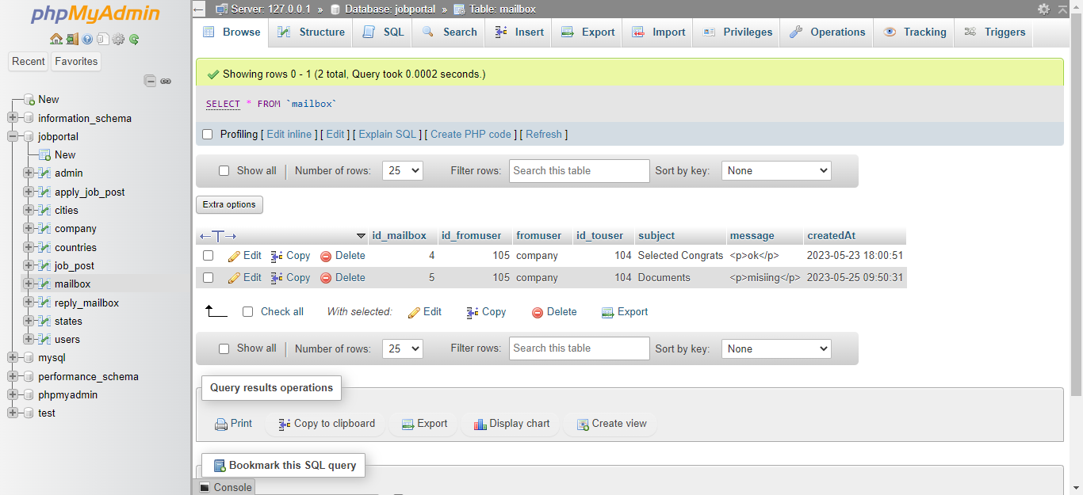

Figure 4.37. Mailbox Table

### Reply Mail Table

The table "reply_mailbox" contains information related to the replies or responses to messages in the "mailbox" table. Here's a description of each column:

* id_reply: It is a unique identifier for each reply in the table.
* id_mailbox: Foreign key referencing id of the message to which the reply belongs.
* id_user: It represents the foreign key referencing the id of the user who sent the reply.
* usertype: It indicates the type of user who sent the reply (e.g., admin, customer, etc.).
* message: It stores the content or body of the reply message.
* createdAt: It denotes the timestamp or date when the reply was created or sent.

The "reply_mailbox" table allows storing and associating replies with the original messages in the "mailbox" table. It helps maintain a conversation thread or history of communication between users or users and administrators.

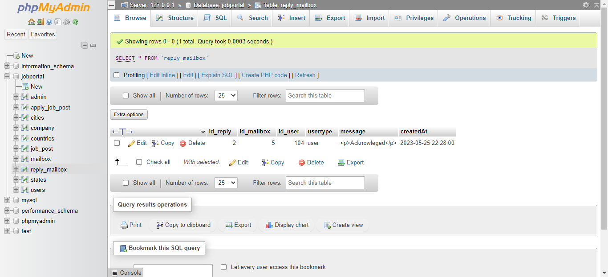

Figure 4.38. Reply Mailbox Table

### States Table

The table "states" contains information about states or provinces. Here's a description of each column:

* id: It is a unique identifier for each state in the table.
* name: It represents the name of the state.
* country_id: It represents the foreign key referencing the id of the country.

The "states" table is typically used to store a list of states or provinces within a country. By linking the states to their respective countries through the country_id column, you can easily retrieve and manage state information based on the country.

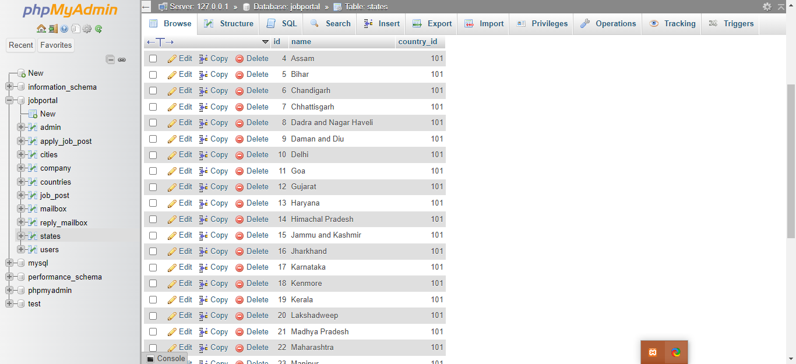

Figure 4.39. State Table

### 4.4.10. Users Table

Brief description of each column in the table:

1. id_user: It represents the unique identifier for each user in the table.

2. firstname: It has the first name of the user.

3. lastname: Saves the last name of the user.

4. email: It stores the email address.

5. password: It stores the encrypted password associated with the user's account.

6. address: It stores the address of the user.

7. city: It stores the city name where the user resides.

8. state: It stores the state or region where the user resides.

9. contactno: It stores the contact number of the user.

10. qualification: It stores the educational qualification of the user.

11. stream: It stores the field or stream of study of the user.

12. passingyear: It stores the year when the user passed their educational qualification.

13. dob: It stores the date of birth of the user.

14. age: It stores the age of the user.

15. cnic: It stores the cnic number of user.

16. resume: It stores the file path or URL of the user's resume or CV.

17. hash: It stores a unique hash value associated with the user's account for security purposes.

18. active: It indicates the activation status of the user's account.

19. aboutme: It stores a brief description or information about the user.

20. skills: It stores the skills or competencies possessed by the user.

These columns collectively store the relevant information about the users in the table, allowing for efficient management and retrieval of user data within the system.

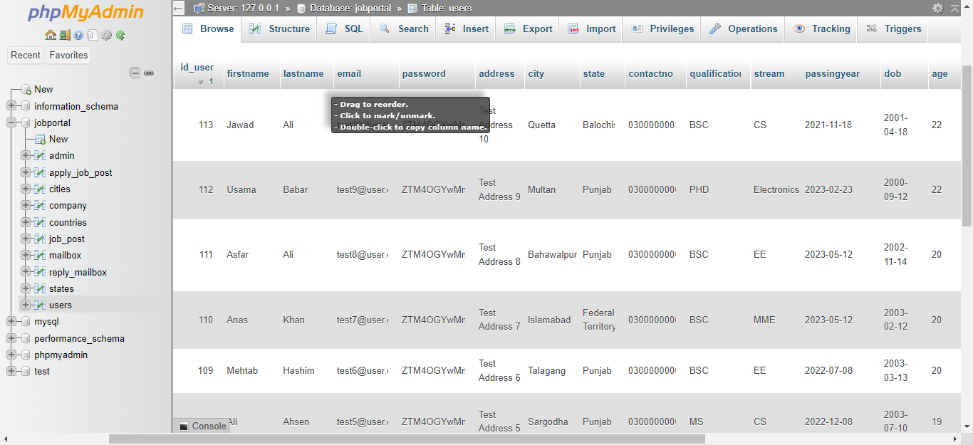

Figure 4.40. User Table

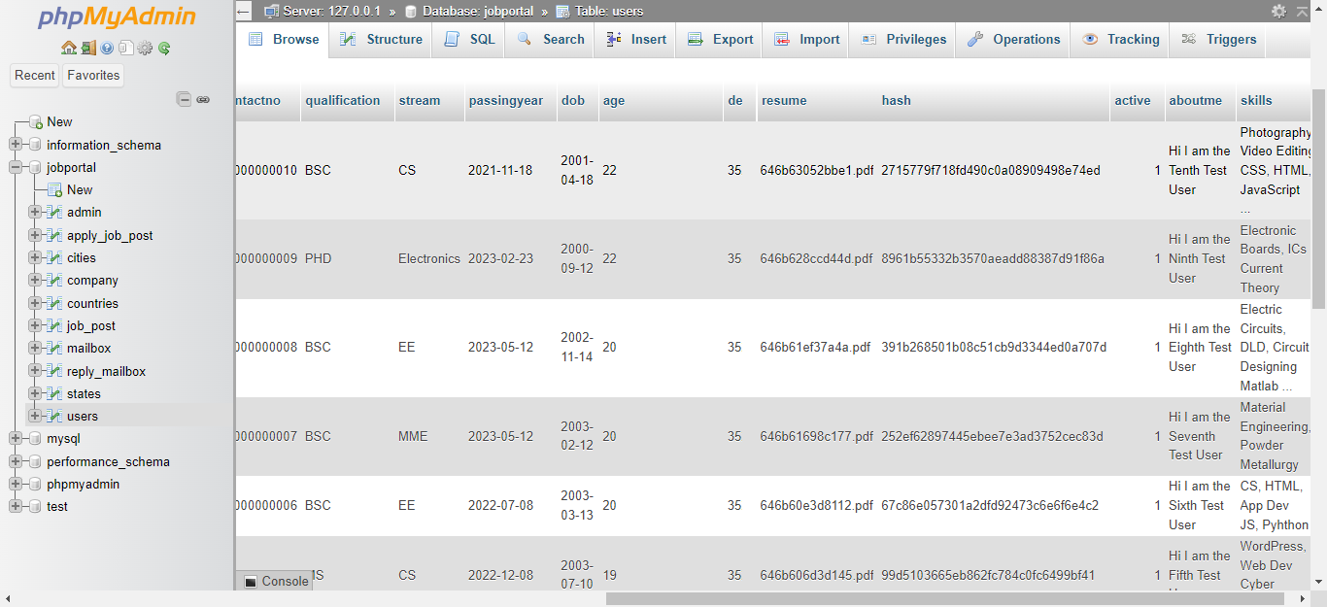

Figure 4.41. User Table

## Web Hosting

A web hosting company called 000webhosting provides both individuals and businesses with cost-free hosting packages. 000webhosting offers users the chance to host their websites for free, making it a desirable option for those looking for hosting services that are affordable.

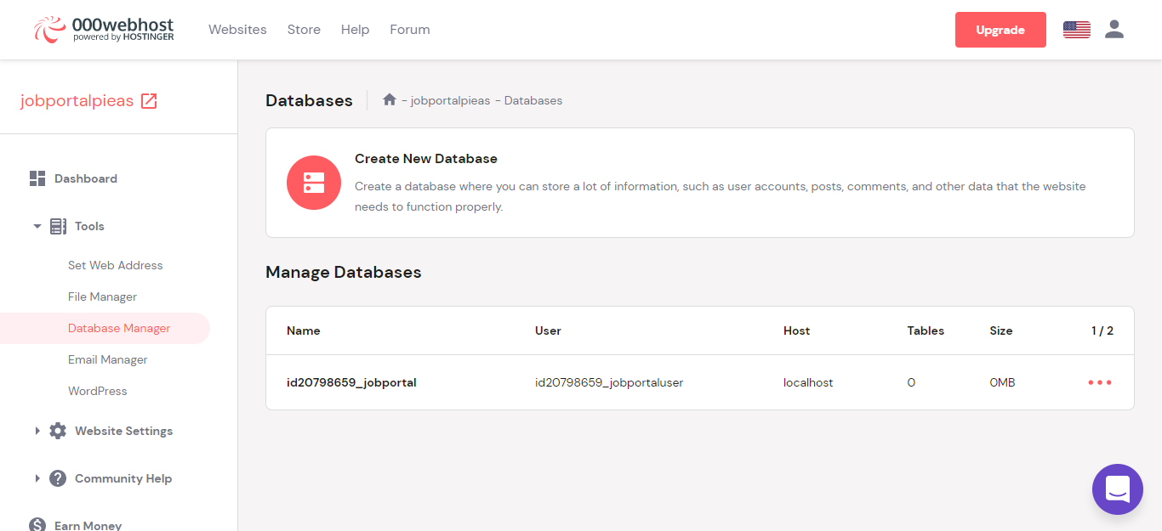

Figure 4.42. Hosting Page

### Backend Management

Users can access a variety of tools and features through 000webhosting's backend management to manage their hosted websites efficiently. Here are some significant components of 000webhosting's backend administration:

* Control Panel: The control panel interface used by 000webhosting enables users to easily navigate and access different management options. Users can manage their hosting preferences, domains, databases, email accounts, and other things using the control panel, which offers a centralized dashboard.
* File Manager: A file manager is a component of the backend administration that enables users to upload, edit, and arrange the files that make up their websites right from the control panel. Users can easily create directories, change file permissions, and operate on files.

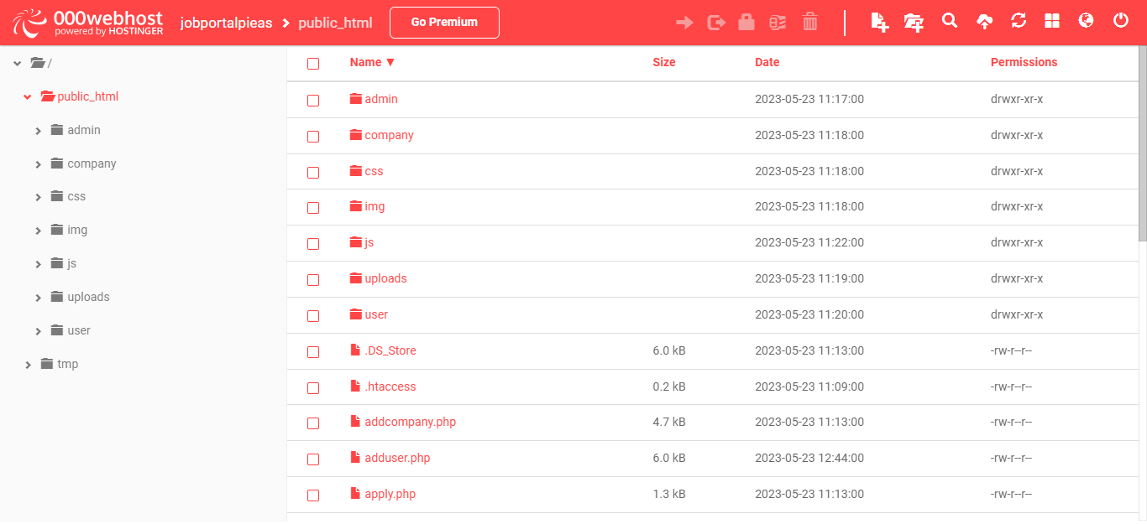

Figure 4.43. Hosting Backend Page

### Database Management

MySQL database management is one of the hosting services provided by 000webhosting. Data can be stored and utilized using open-source relational database management system MySQL. A user-friendly MySQL management interface is available to users with 000webhosting, making it easier for them to create, manage, and interact with databases[15]

* Database creation is simple for users and is done right from the hosting control panel. You must enter a database name, username, and password to complete the process. Users can use the newly created database for their content management systems or web applications.
* phpMyAdmin: To run and control the MySQL databases, we used 000webhosting which gave us the phpMyAdmin, it is a web-based database management tool, with a user interface for managing tables, running SQL queries, impor and export of data.

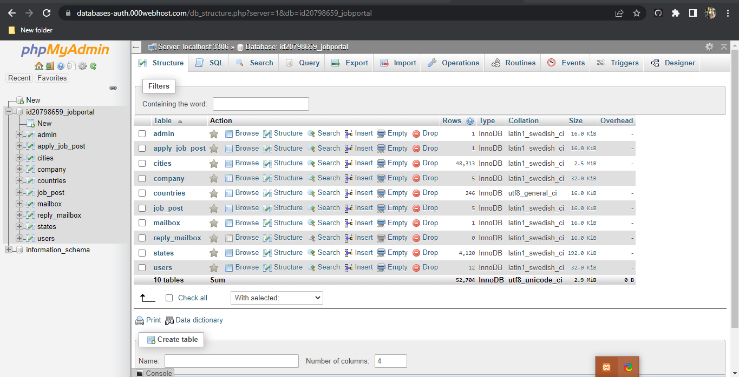Figure 4.44. Hosting Database

# Chapter 5: Structure

The structures of the project are shown in this chapter, from front end webpage structural diagrams to the back end’s relations, context etc. to the database.

## Front End Structural Diagram

The Front End Structure of the system is as following:

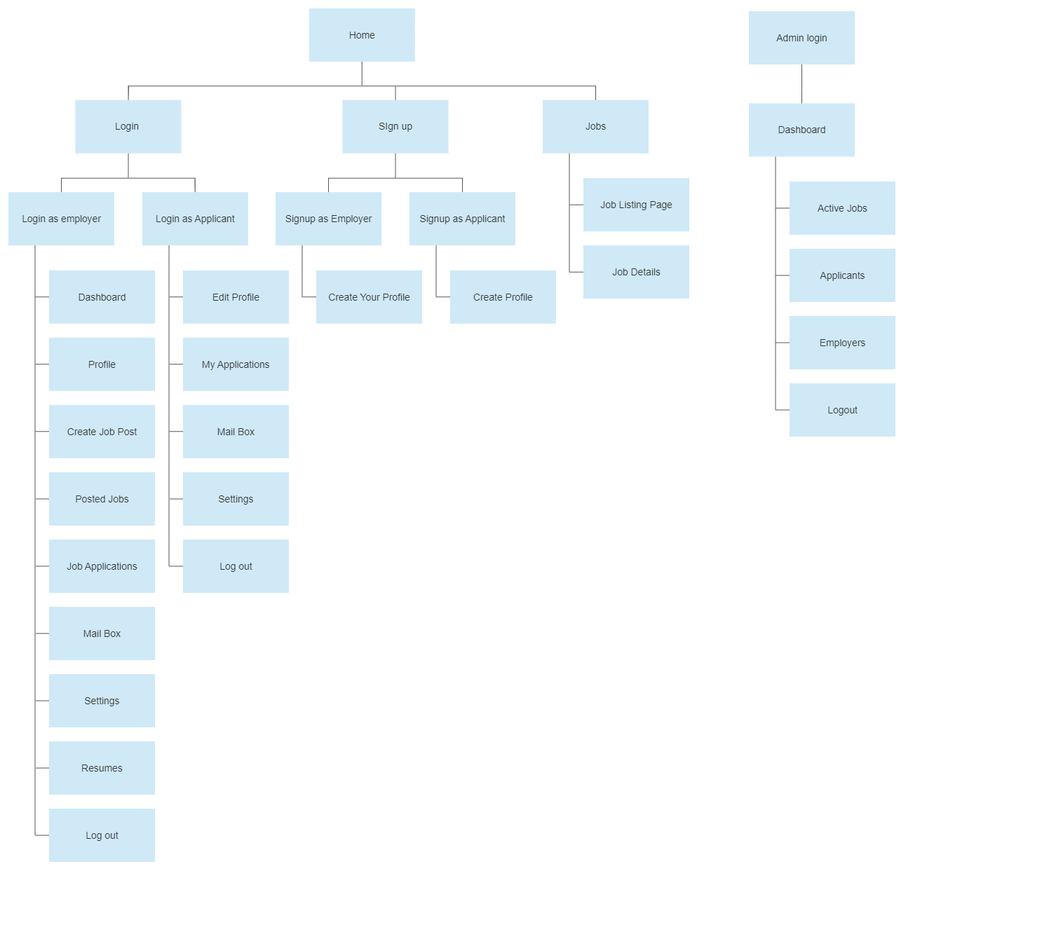 Figure 5.1. Structural Diagram

## Backend and Database Diagrams

Following are the Databases and Back End’s Diagrams:

### ER Diagram

The Entity Relation Diagram for the system is as follows:

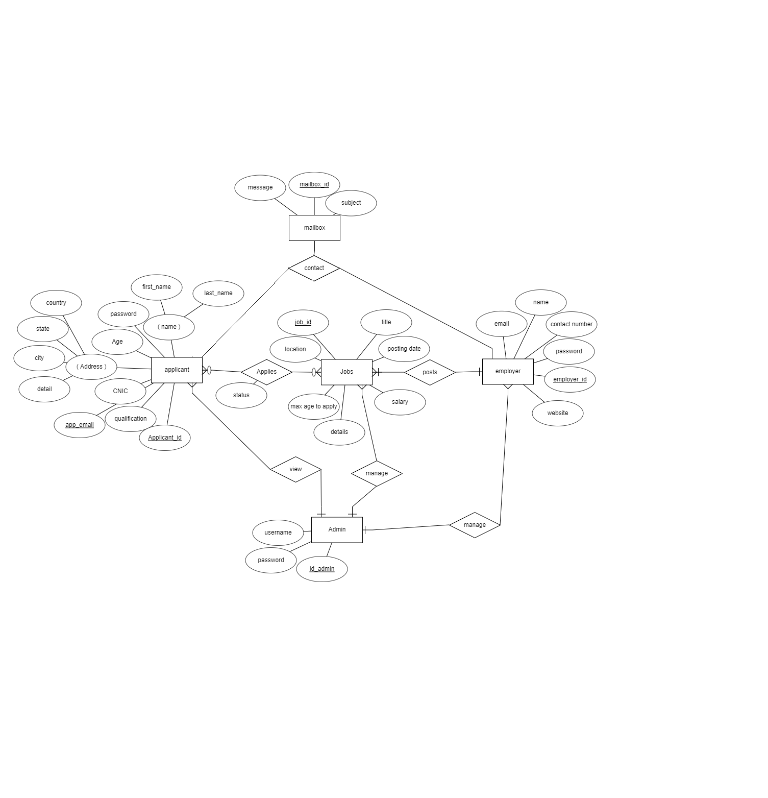 Figure 5.2. ER Diagram

### Use Case Diagram

The Use Case Diagram for the system is as follows:

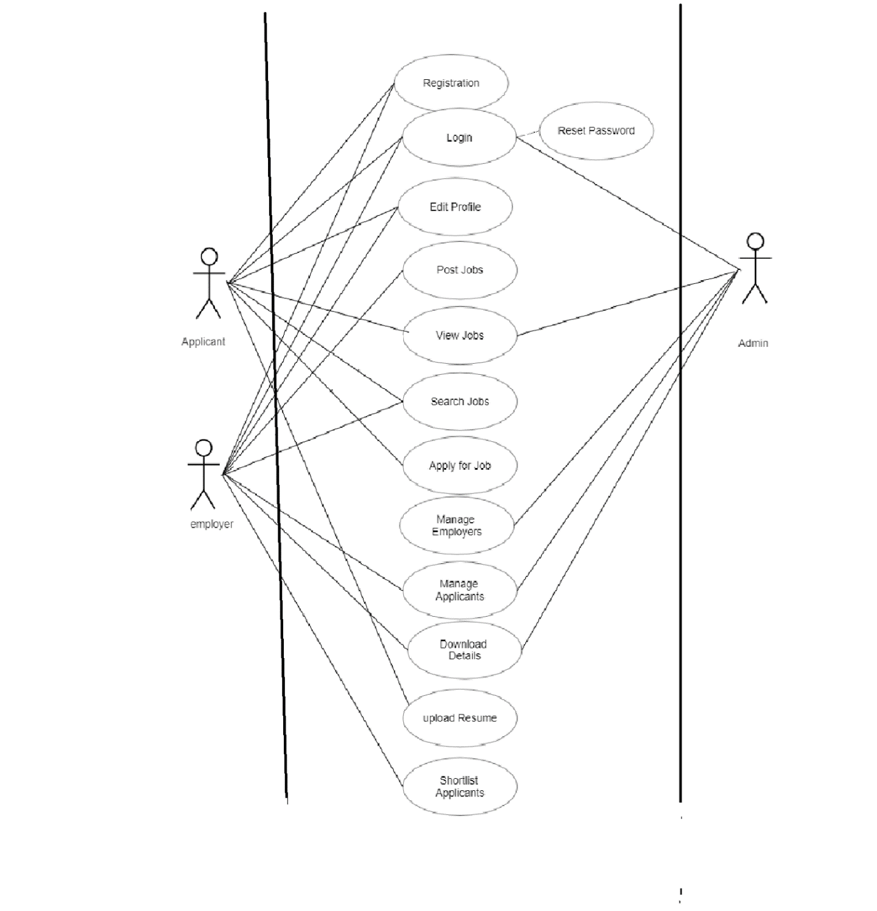

Figure 5.3. Use Case Diagram

### Context Diagram

The Context Diagram for the system is as follows:

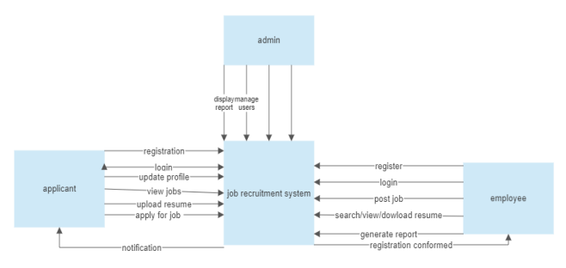

Figure 5.4. Context Diagram

### Relational Schema

The relational schema for this system is as shown below:

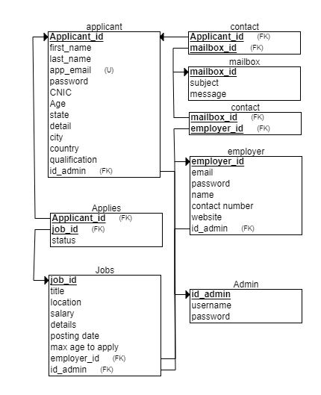

Figure 5.5. Relational Schema

# Chapter 6: User Roles

There are 3 users of the system and each of them plays a major role in making the portal achieve its goal hence there are user roles for each one, their functions, features and roles are set accordingly, they are described below:

## . Administrator

As the system administrator and super user for the Job Recruitment Portal, the admin is essential. The management of the portal's general operations is their main duty. Administrators can manage the database, supervise accounts, and uphold system security due to their privileged access to the system.

They are able to add, change, or remove accounts, including those for employers. To gain insight into job postings, applications, and user activity, the admin can track the portal's performance, generate reports, and examine system statistics. Administrators may also be able to modify features, set up system preferences, and fix technical problems.

Overall, the administrator's function is crucial to preserving the reliability, security, and effectiveness of the Job Recruitment Portal.

## . Employer

Employers are essential to the Job Recruitment Portal because they are in charge of managing the hiring process and posting job listings. Their main responsibility is to write and post job descriptions that include information about the position's title, requirements, and deadline for applications. Employers are able to look over and assess applicant profiles, resumes, and other supporting materials. They are able to interact with candidates, plan interviews, and make selections. Additionally, employers may have the power to mark applicants as chosen or rejected for particular job positions.

They can also track the progress of their job postings and applications, as well as download applicant resumes. Employers' primary responsibilities when using the Job Recruitment Portal are to find, evaluate, and hire qualified applicants for their organizations.

## . Applicant / Candidate

Candidates can set up profiles with both personal and professional information, such as their qualifications, training, and experience. They can use filters like job title, location, and keywords to search and browse through the available job listings. To decide whether they are qualified, candidates can review the job descriptions, prerequisites, and application deadlines. Applicants can submit their applications, which ordinarily involve uploading their resumes and other documents, once they locate a desirable job.

During the hiring process, candidates can monitor the progress of their applications, get notifications, and possibly communicate with employers. In the Job Recruitment Portal, applicants' roles are to actively engage in the job search, submit applications for positions that fit their qualifications, and market themselves to prospective employers as qualified candidates.

# Chapter 7: Conclusion & Future Works

As the final chapter, it is the conclusion of the whole project where we started from the basic languages needed, tools and technologies and moved along the development of the front end, backend and the database from there moved to the structure of the system and discussed user roles for each of our 3 user types. Furthermore, we also have some future works for this.

## 7.1. Conclusion

In conclusion, the creation of a job recruitment portal has the potential to revolutionize the hiring procedure, bringing advantages to both employers and candidates. Employers can post job openings, review applicants, and choose qualified candidates on the portal's user-friendly and effective platform. On the other hand, candidates can quickly search for pertinent job openings and easily submit their applications.

To guarantee the effectiveness and success of the portal, various functional and non-functional requirements were taken into account throughout the development process. A scalable, secure, and dependable platform that can support a large number of users while maintaining data integrity was provided by the system architecture. In order to efficiently organize and manage job listings, applicant profiles, and communication records, a database design was carefully created.

The Job Recruitment Portal seeks to minimize the delays, inefficiencies, and missed opportunities frequently connected to conventional recruitment techniques by streamlining the hiring procedure. Employers can save time and effort by reviewing and choosing candidates more quickly, and candidates can easily access a variety of job opportunities and present their qualifications. The intuitive features and user-friendly interface of the portal improve the overall user experience.

The Job Recruitment Portal ensures a reliable and responsive system by integrating technologies like HTML, CSS, MySQL, and suitable frameworks. Key evaluation metrics include performance, usability, and user satisfaction. The results have an impact on the job recruitment industry and offer insightful information for potential future improvements.

Overall, the Job Recruitment Portal is an important tool for bridging the gap between employers and applicants, providing a modern and efficient platform that streamlines the recruitment process and improves the overall experience for all stakeholders. The portal, if successfully implemented, can contribute to increased efficiency, better candidate selection, and increased job opportunities in a competitive job market.

## 7.2. Future Works

Future efforts will aim to improve job matching, streamline processes, and make better use of emerging technologies to improve user experience and make the job portal more effective and user-friendly. The potential future works that can be done include adding

### 7.2.1. Live Interviewing:

By incorporating live interviewing features into the job portal, employers will be able to conduct virtual, on-demand interviews with candidates. In order to facilitate remote interviews and remove geographic restrictions, this may include features like video conferencing, chat capabilities, screen sharing, and recording options.[16]

### 7.2.2. Enhanced Search and Filtering:

Users will be able to focus their job searches based on details like location, salary range, job type, experience level, and more by using advanced search and filtering options.

### 7.2.3. Personalized Recommendations:

Creating algorithms to offer users personalized job suggestions based on their abilities, backgrounds, and preferences. This could enhance the process of matching jobs and boost user satisfaction.[17]

### 7.2.4. Mobile Application:

To give mobile users a seamless and user-friendly experience, a mobile application is being created for the job portal. Features like job alerts, mobile application submission, and simple access to user profiles can be part of this.

# References

[1] “HTML Tutorial.” https://www.w3schools.com/html/ (accessed May 26, 2023).

[2] “CSS Tutorial.” https://www.w3schools.com/css/default.asp (accessed May 26, 2023).

[3] “JavaScript Tutorial.” https://www.w3schools.com/js/default.asp (accessed May 26, 2023).

[4] “W3Schools Free Online Web Tutorials.” https://www.w3schools.com/bootstrap/bootstrap_ver.asp (accessed May 26, 2023).

[5] “PHP Tutorial.” https://www.w3schools.com/php/default.asp (accessed May 26, 2023).

[6] “MySQL.” https://www.mysql.com/ (accessed May 29, 2023).

[7] “XAMPP Installers and Downloads for Apache Friends.” https://www.apachefriends.org/ (accessed May 26, 2023).

[8] “What Is Apache? What Is a Web Server?” https://www.wpbeginner.com/glossary/apache/ (accessed May 29, 2023).

[9] “What Is GitHub? | Definition from TechTarget.” https://www.techtarget.com/searchitoperations/definition/GitHub (accessed May 29, 2023).

[10] “Free Web Hosting - Host a Website for Free with Cpanel, PHP,” *Free Web Hosting*. https://www.000webhost.com/ (accessed May 26, 2023).

[11] “What is User Interface (UI) Design?,” *The Interaction Design Foundation*. https://www.interaction-design.org/literature/topics/ui-design (accessed May 29, 2023).

[12] “Computer Network | Application Layer - javatpoint.” https://www.javatpoint.com/computer-network-application-layer (accessed May 29, 2023).

[13] “The database layer | Solutions Architect’s Handbook.” https://subscription.packtpub.com/book/programming/9781838645649/6/ch06lvl1sec22/the-database-layer (accessed May 29, 2023).

[14] “403 Forbidden.” https://cis.msjc.edu/IA/DatabaseLayer/ (accessed May 29, 2023).

[15] phpMyAdmin contributors, “phpMyAdmin,” *phpMyAdmin*. https://www.phpmyadmin.net/ (accessed May 26, 2023).

[16] “What is a Live Interview?,” *HireVue Candidate Help Center*, Mar. 14, 2022. https://hirevuesupport.zendesk.com/hc/en-us/articles/360028139332-What-is-a-Live-Interview- (accessed May 26, 2023).

[17] “What are personalized recommendations? | Algolia,” *Algolia Blog*. https://algolia.com/blog/ux/what-are-personalized-recommendations-and-how-can-they-boost-engagement-and-conversion/ (accessed May 26, 2023).

# Appendix A – Installation and Setup

This is a brief installation and setup guide for running the project for yourself.

1. **Install Xampp**

* Download and Install XAMPP: Visit the Apache Friends website (https://www.apachefriends.org/) and download the appropriate version of XAMPP for your operating system. Follow the installation instructions provided by XAMPP to complete the installation process.
* Start XAMPP: Once the installation is complete, start the XAMPP control panel. You will typically find it in the installation directory or in your Start menu.
* Start Apache and MySQL: In the XAMPP control panel, click the "Start" button next to Apache and MySQL modules. This will start the Apache web server and the MySQL database server

1. **Database Setup**

* Open a web browser and visit http://localhost/phpmyadmin to access phpMyAdmin, the MySQL database administration tool provided by XAMPP. Click on "New" to create a new database for the Job Portal project. Provide a name for the database and click "Create".
* Configure the database connection: Open the db.php file located in the includes directory of the cloned project. Modify the database connection details such as hostname, username, password, and database name according to your XAMPP configuration. Save the changes.

1. **Adding Files and Running on Local Host**

* After it, Move the project: Move the entire files into the htdocs directory of your XAMPP installation

1. **Running the server for Local Host**

* Now Start the server: You need a web server with PHP support to run the Job Portal. If you have a local development environment like XAMPP, WAMP, or MAMP, copy the project folder (job-portal) to the web server's document root directory. Start the web server
* Access the Job Portal: Open a web browser and enter the following URL: http://localhost/job-portal. This will load the Job Portal application.

# Appendix B – Libraries Used in Project

Name and purpose of libraries used in this project:

### Bootstrap

The code includes references to Bootstrap CSS and JS files. Bootstrap is a popular front-end framework that provides pre-designed components and styles for building responsive web applications.

### Font Awesome

The code includes a reference to the Font Awesome CSS file. Font Awesome is a library of scalable vector icons that can be easily customized and used in web projects.

### AdminLTE

The code includes references to AdminLTE CSS and JS files. AdminLTE is a popular open-source admin dashboard template built with Bootstrap. It provides a set of responsive components and styles for building admin interfaces.

### Data Tables

The code includes references to DataTables CSS and JS files. DataTables is a powerful jQuery plugin that enhances HTML tables by adding features such as pagination, sorting, searching, and more.